

**Batch: B–1 Roll No.: 16010422234 Experiment No.: 05**

**__________________________________________________________________________**

**Aim:** To installed Docker, pull and run images from Docker Hub, modify containers to run an application and push it on the Docker Hub

**__________________________________________________________________________**

**Resources needed:** Docker Hub Account

**__________________________________________________________________________**

**Theory:**

**Docker** is an OS-level virtualization software platform that helps users in building and managing applications in the Docker environment with all its library dependencies.

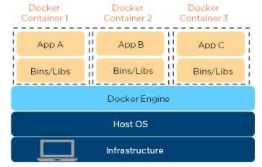

**Docker image** is a read-only, inert template that comes with instructions. In Docker, everything basically revolves around images. An image consists of a collection of files (or layers) that pack together all the necessities—such as dependencies, source code, and libraries—needed to set up a completely functional container environment. Images are stored on a Docker registry, such as the [Docker Hub,](https://hub.docker.com/) or on a local registry.

[**Docker Container**](https://www.simplilearn.com/tutorials/docker-tutorial/what-is-docker-container)is a lightweight software package that includes all the dependencies (frameworks, libraries, etc.) required to execute an application. Running image is the container.

**__________________________________________________________________________**

**Procedure:**

1. Create Account on Docker Hub
2. Install Docker and explore Docker commands on windows/VM Linux AWS
3. Pull Nginx web server image and set the port
4. Check working of Nginx container on local host/live on browser(if it is VM)
5. Push Nginx image on your Docker Hub
6. Repeat the same for **two** other images of your choice to run an application/program. [Hello world, Ubuntu etc.]

**__________________________________________________________________________**

**Results: (Document with screenshots)**

1. All steps to Create Docker Hub Account and install Docker
2. 10 Docker commands
3. All commands to pull images, set path, modify, website hosting and push
4. Updated Docker hub repository (before push and after push)

**__________________________________________________________________________**

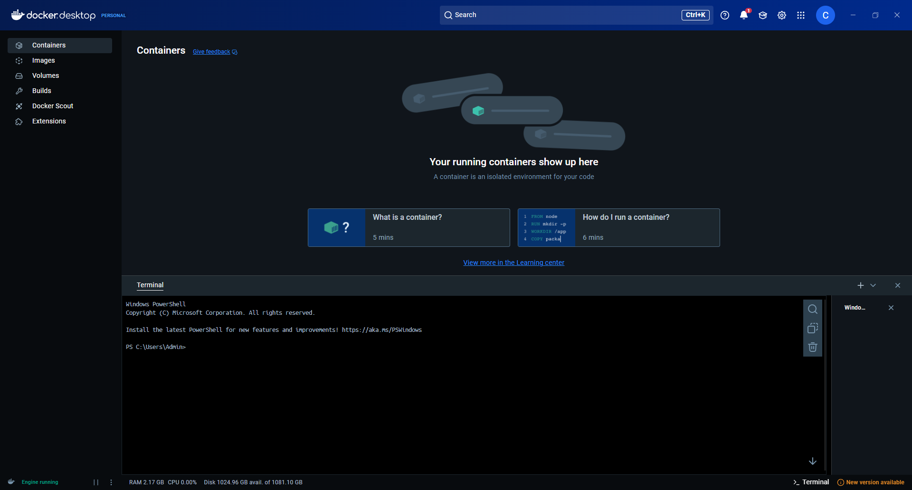

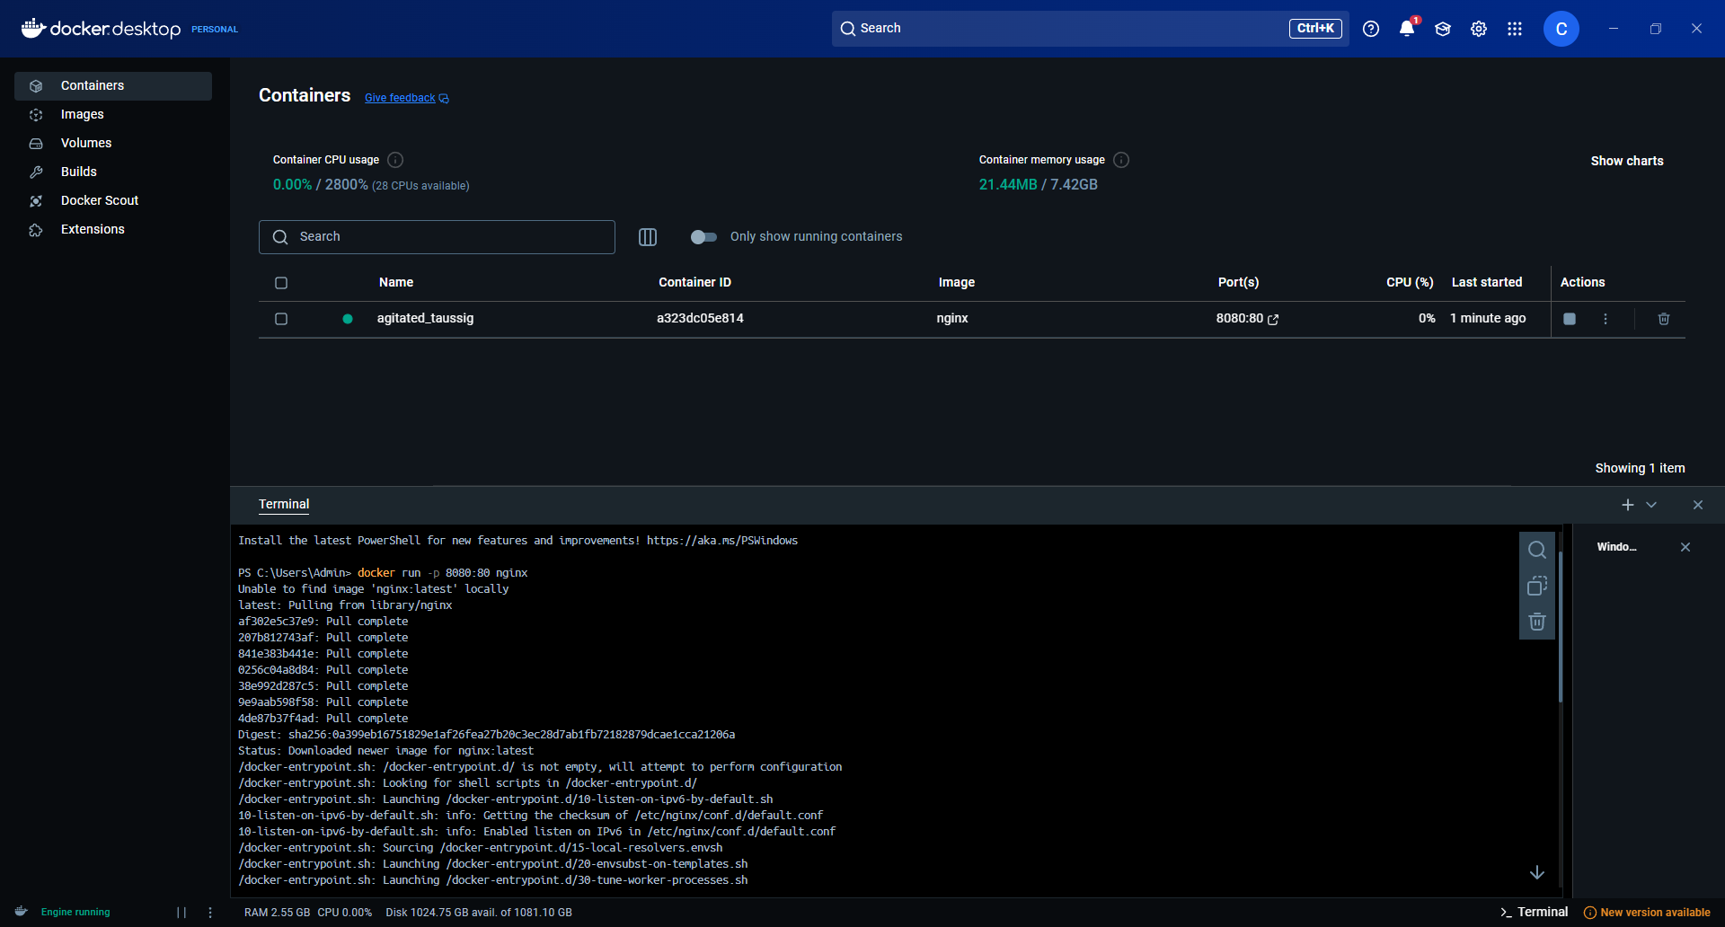

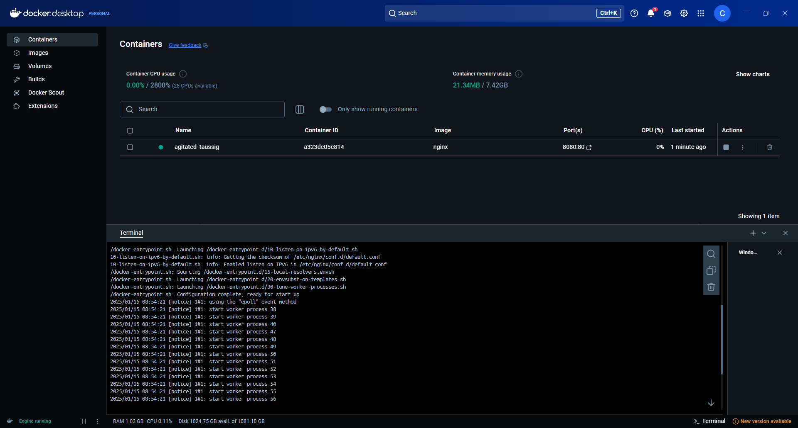

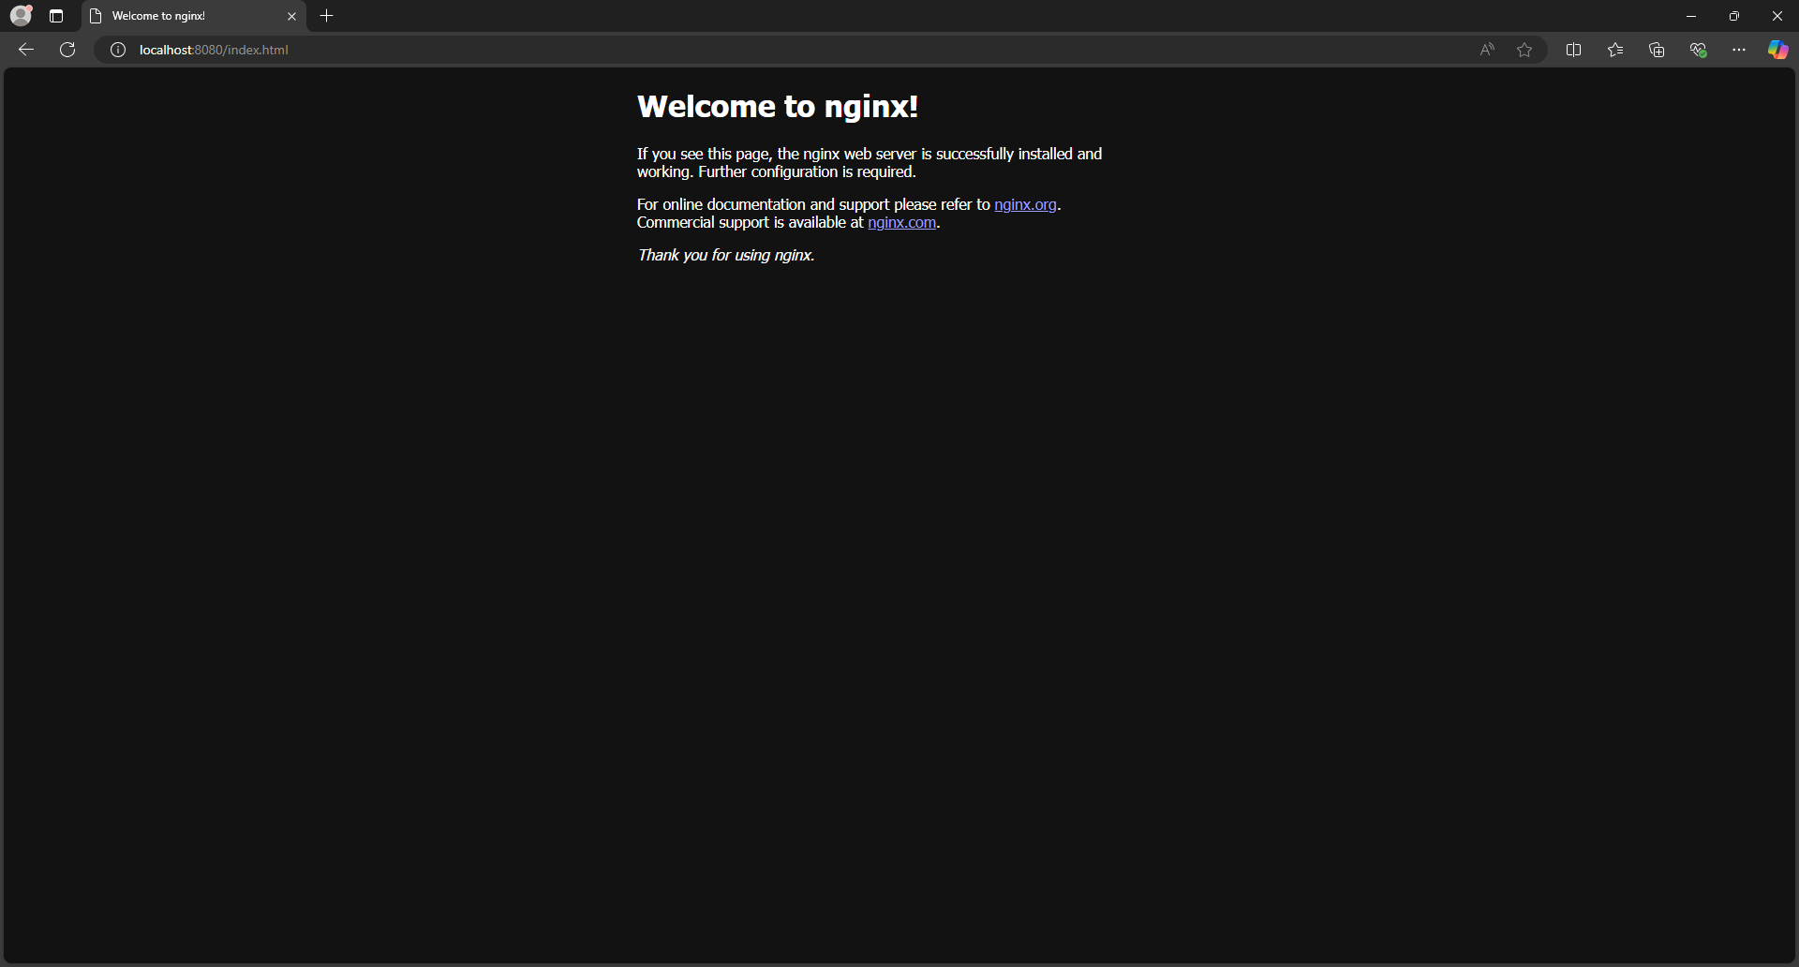

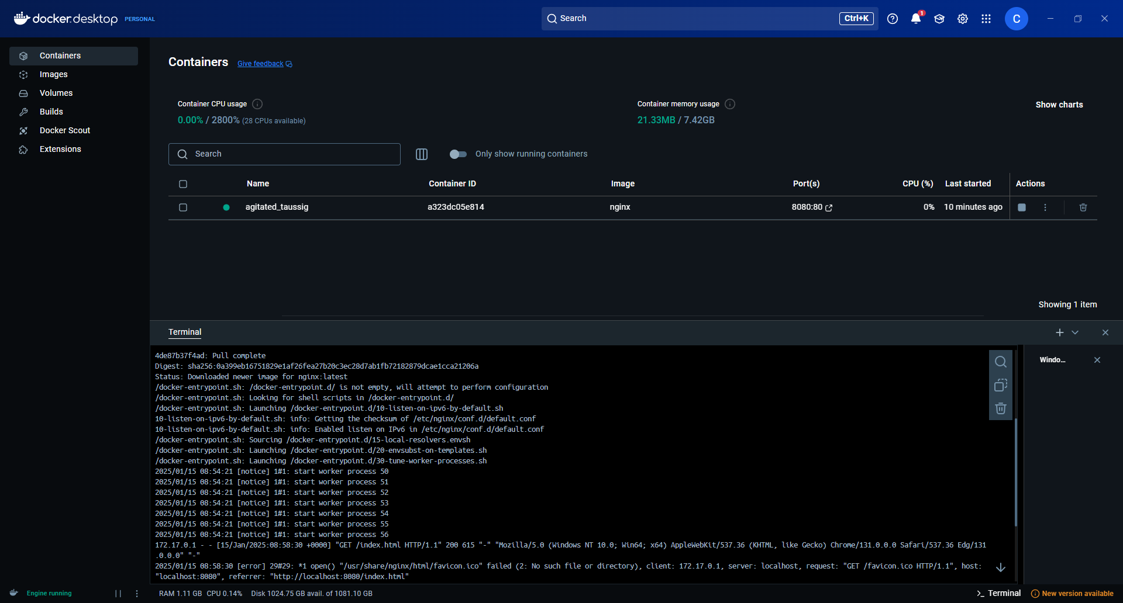

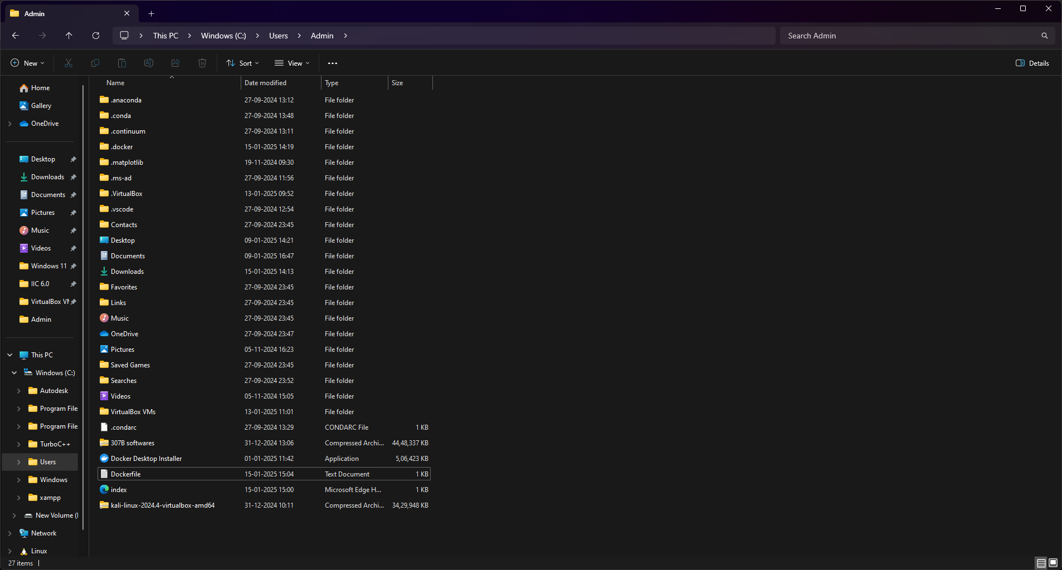

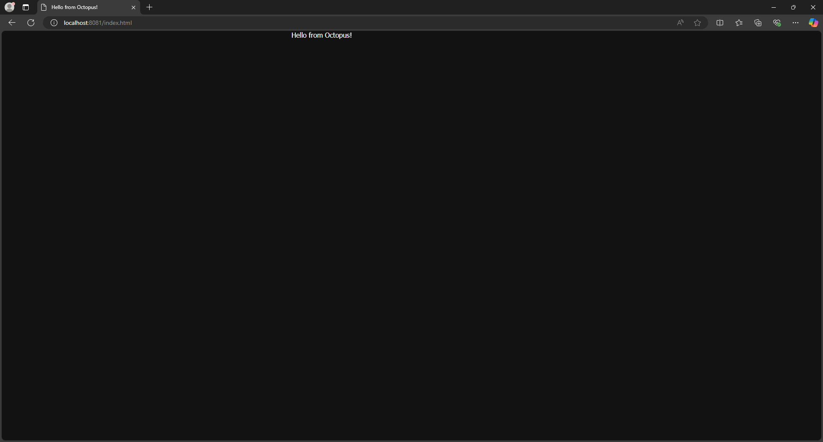

**Create an Account on Docker Hub**

**Install Docker and Explore Docker Commands**

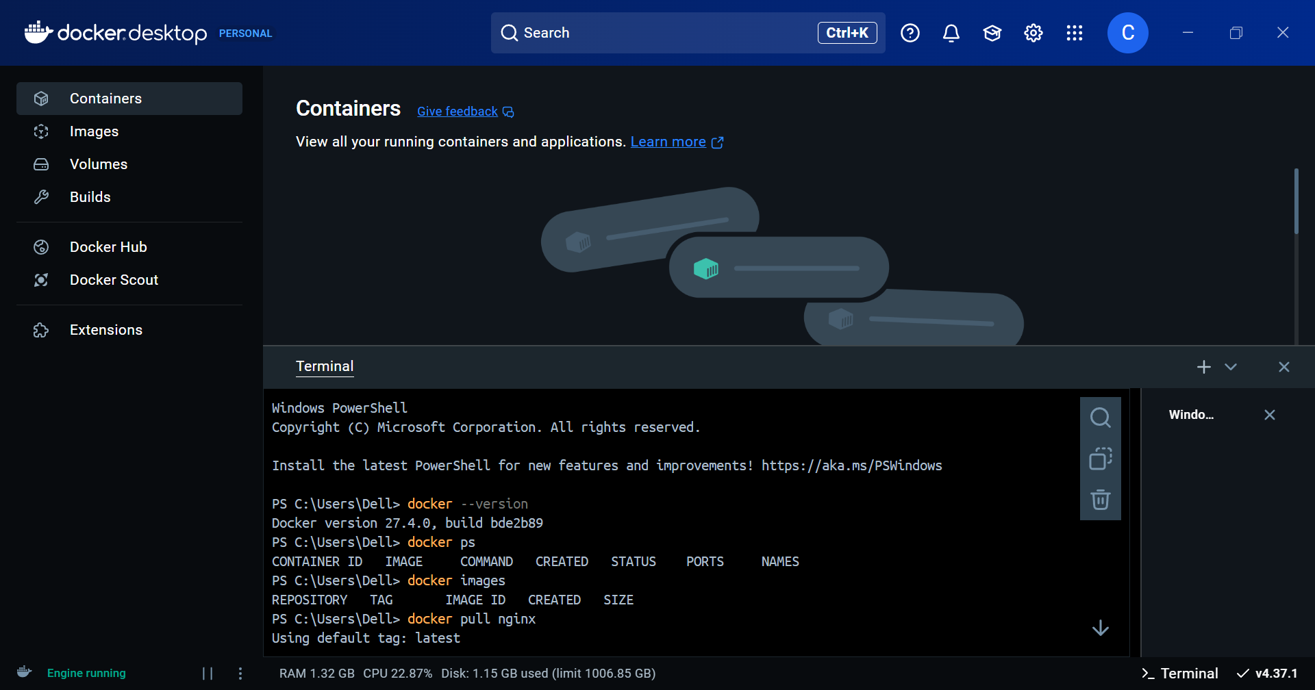

**Pull NGINX Web Server Image and Set the Port**



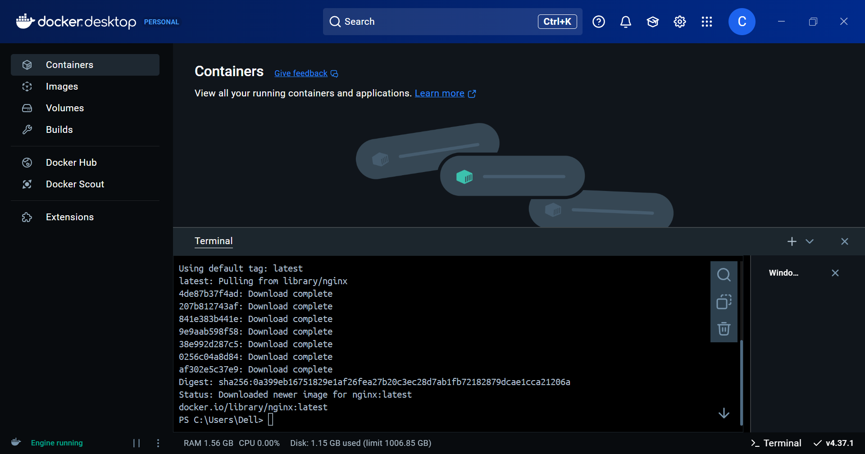

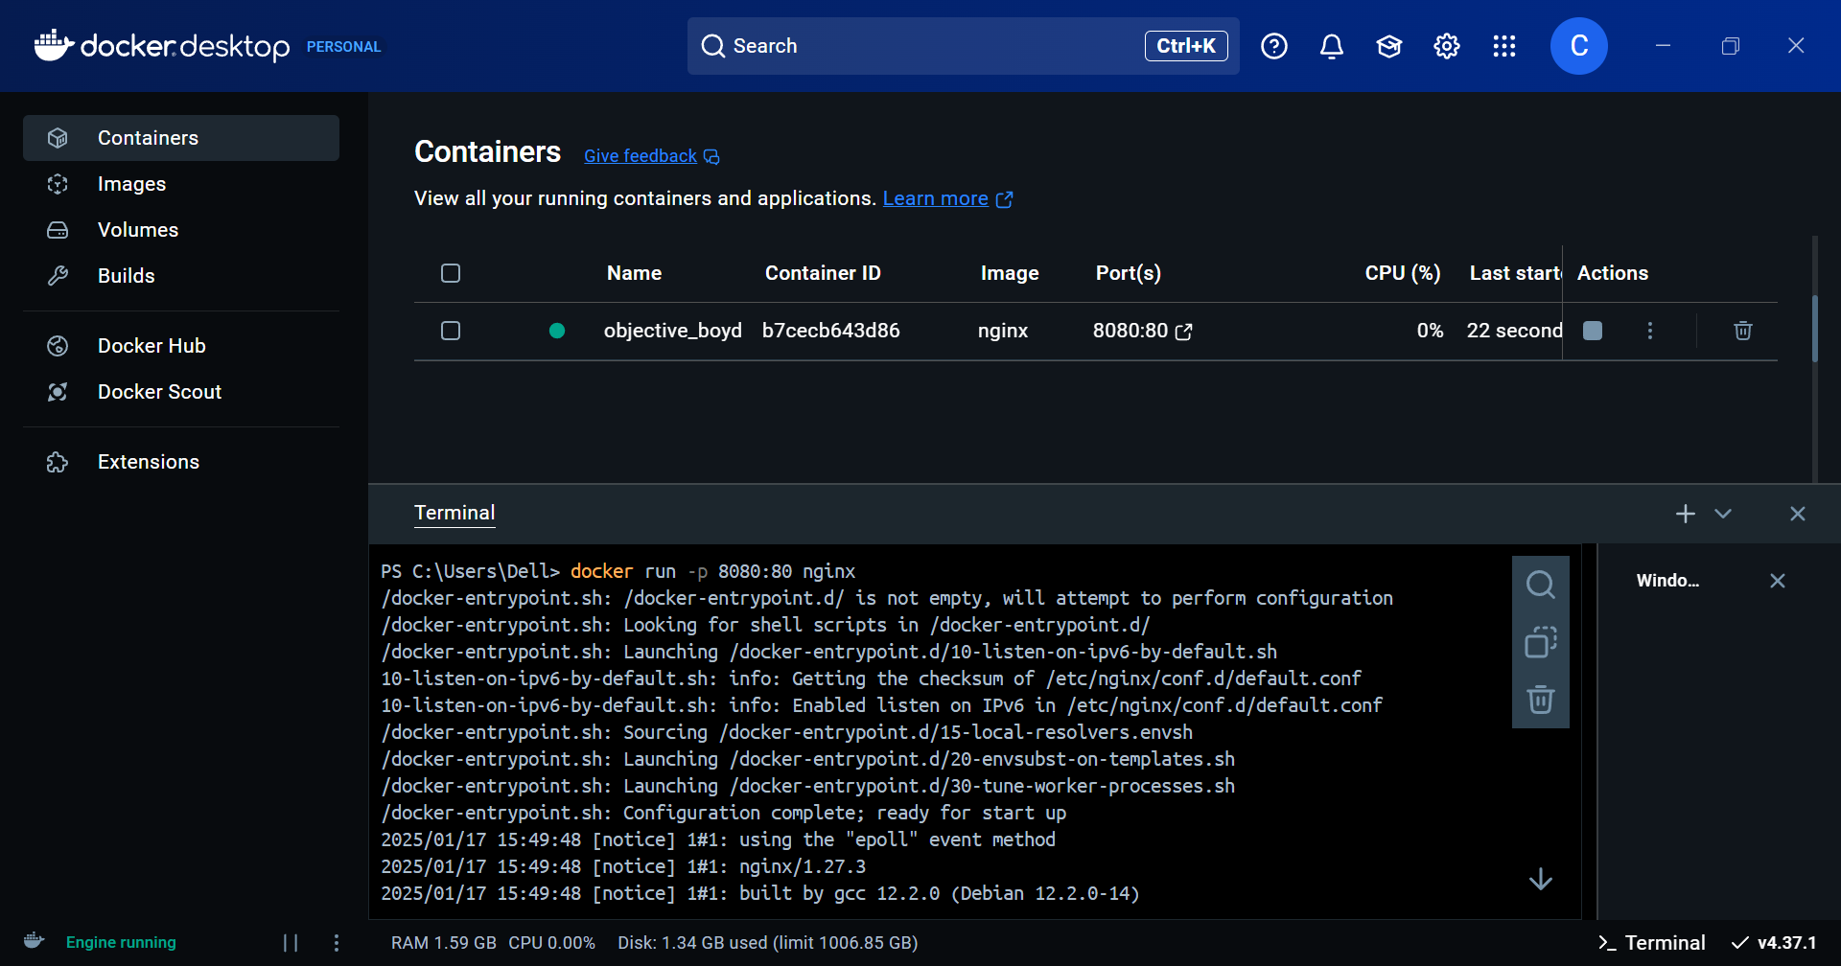

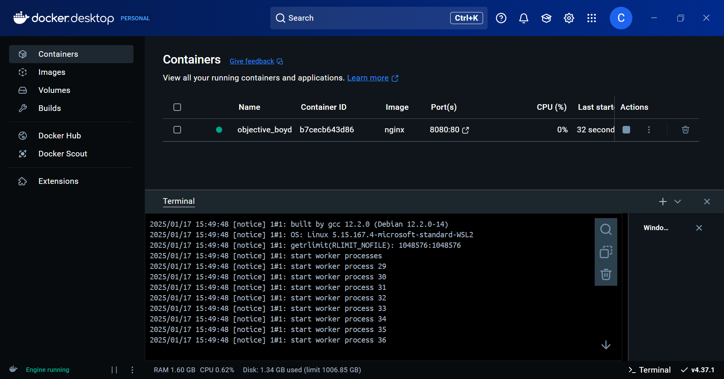

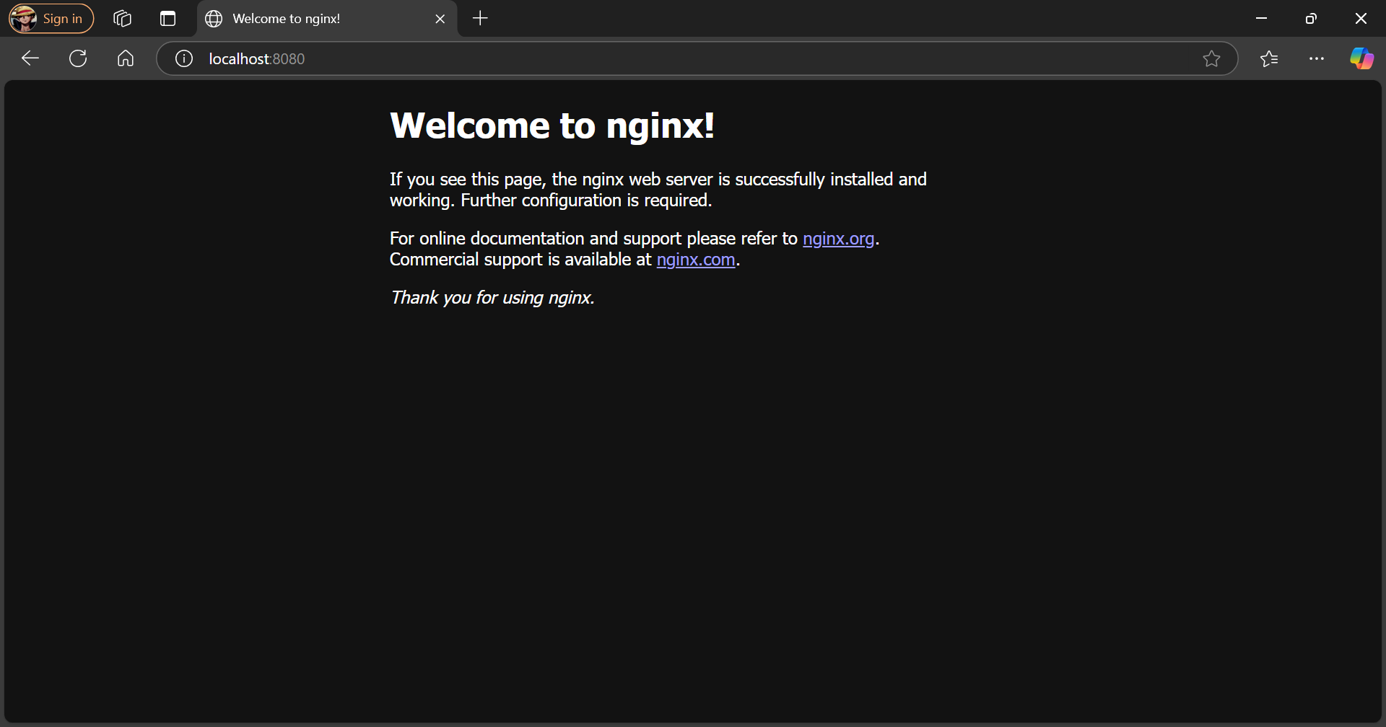

**Modify the NGINX Container**

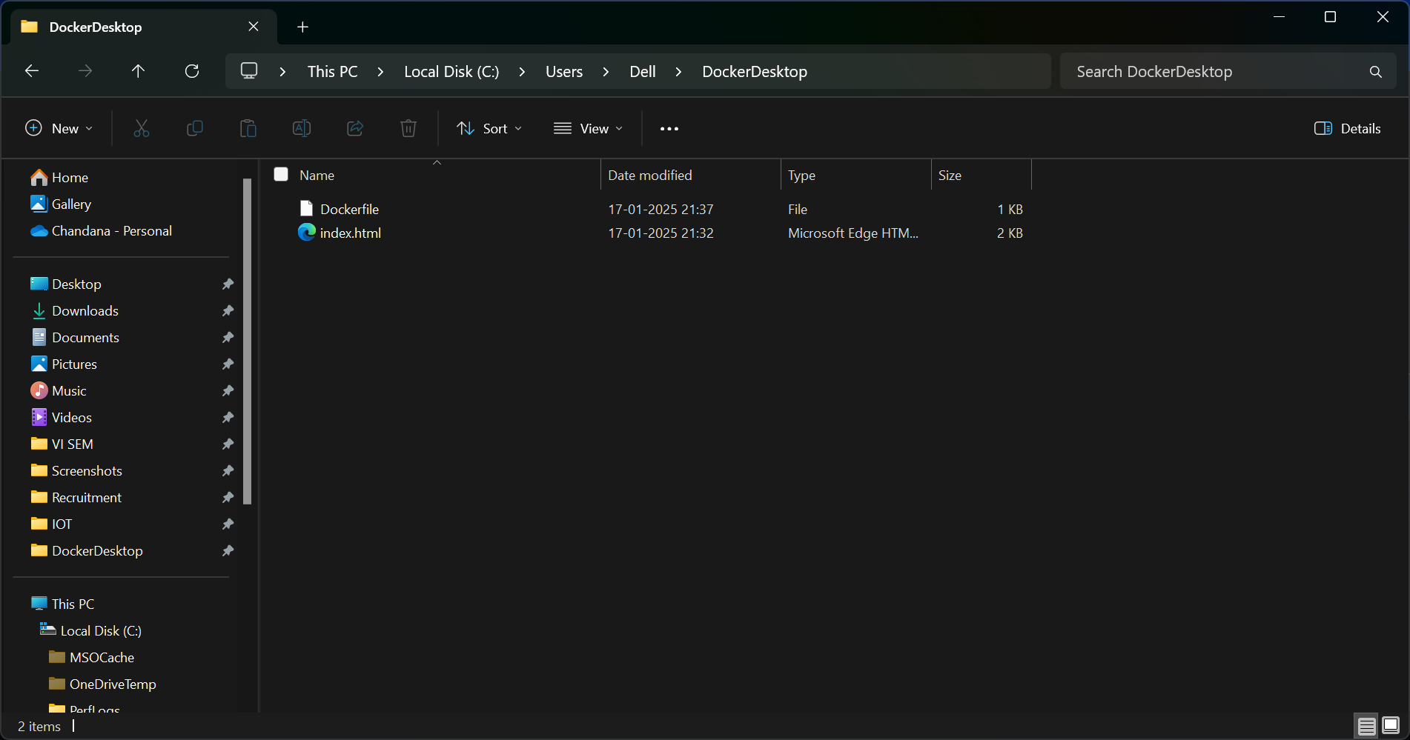

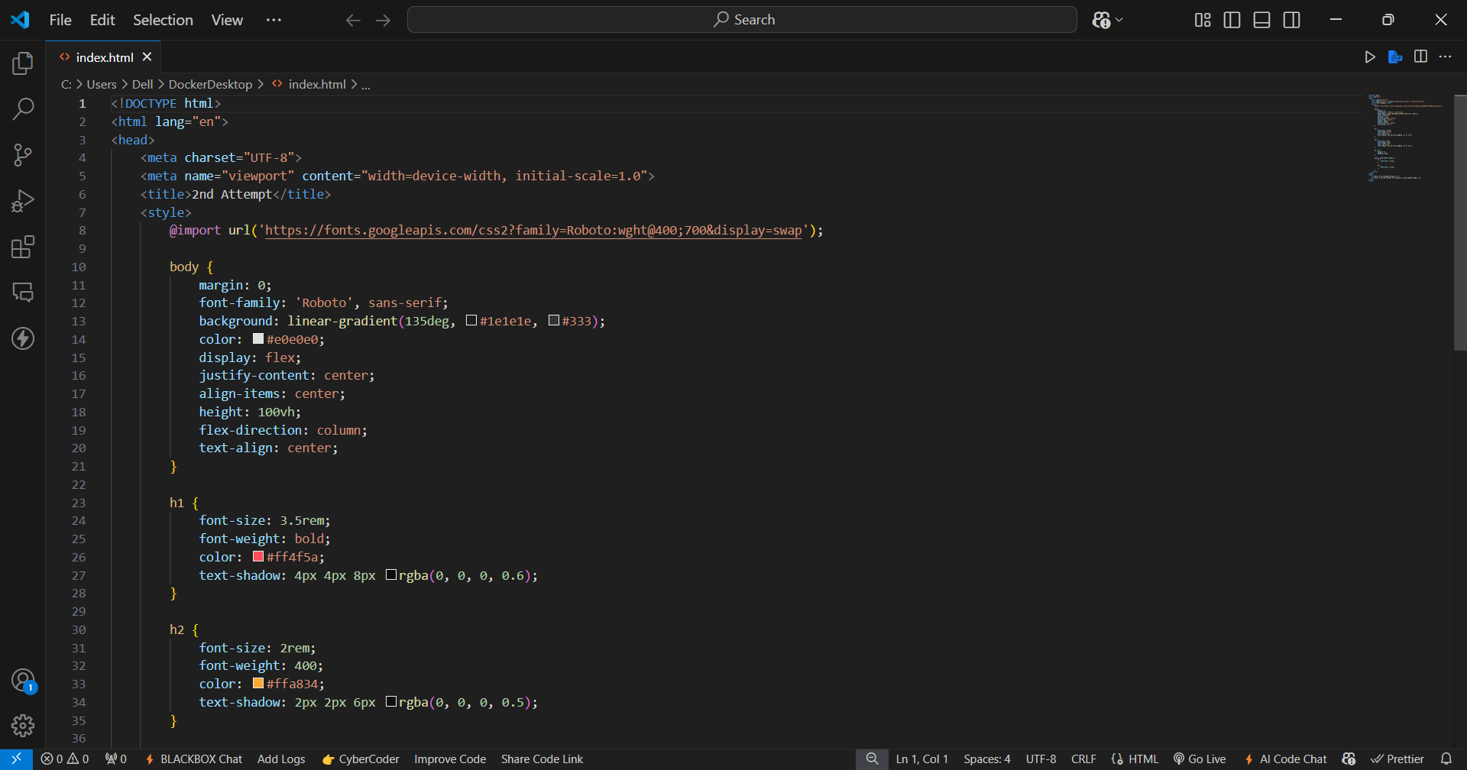

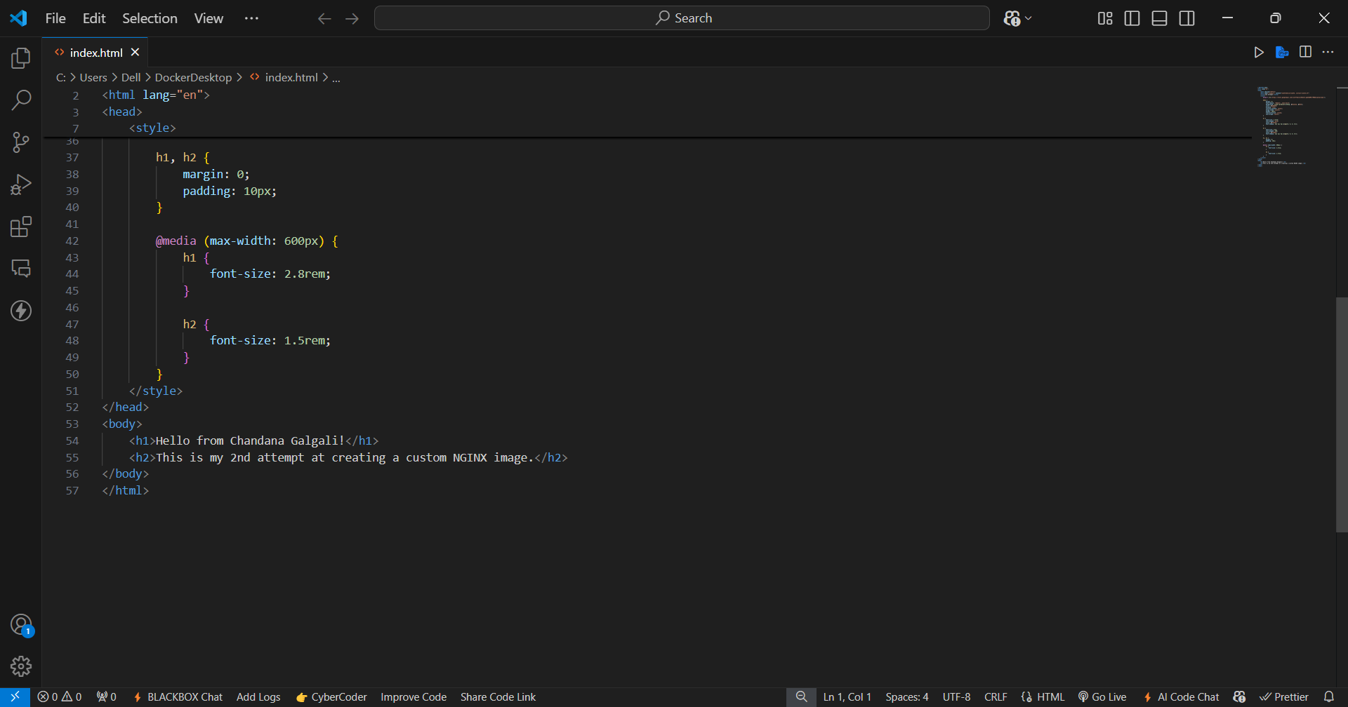

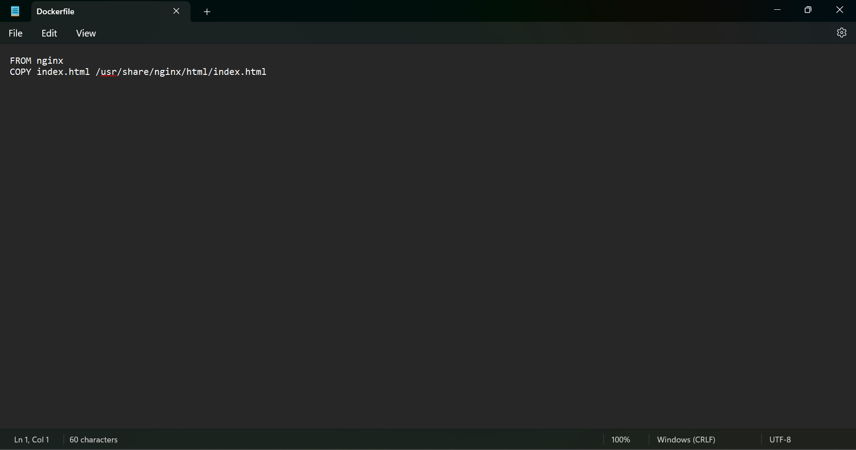

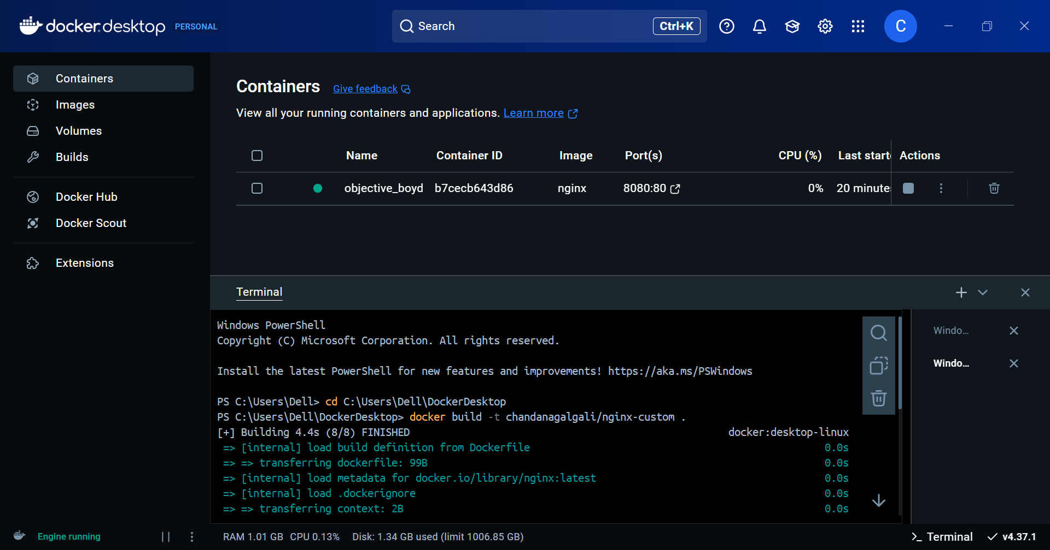

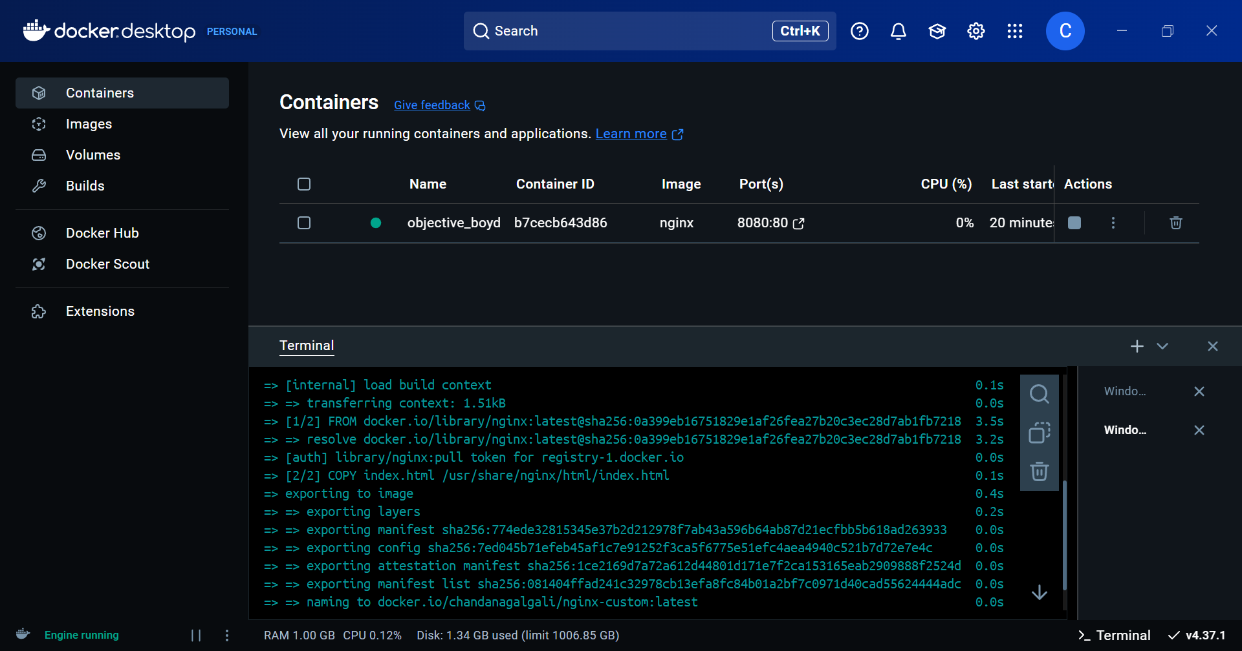

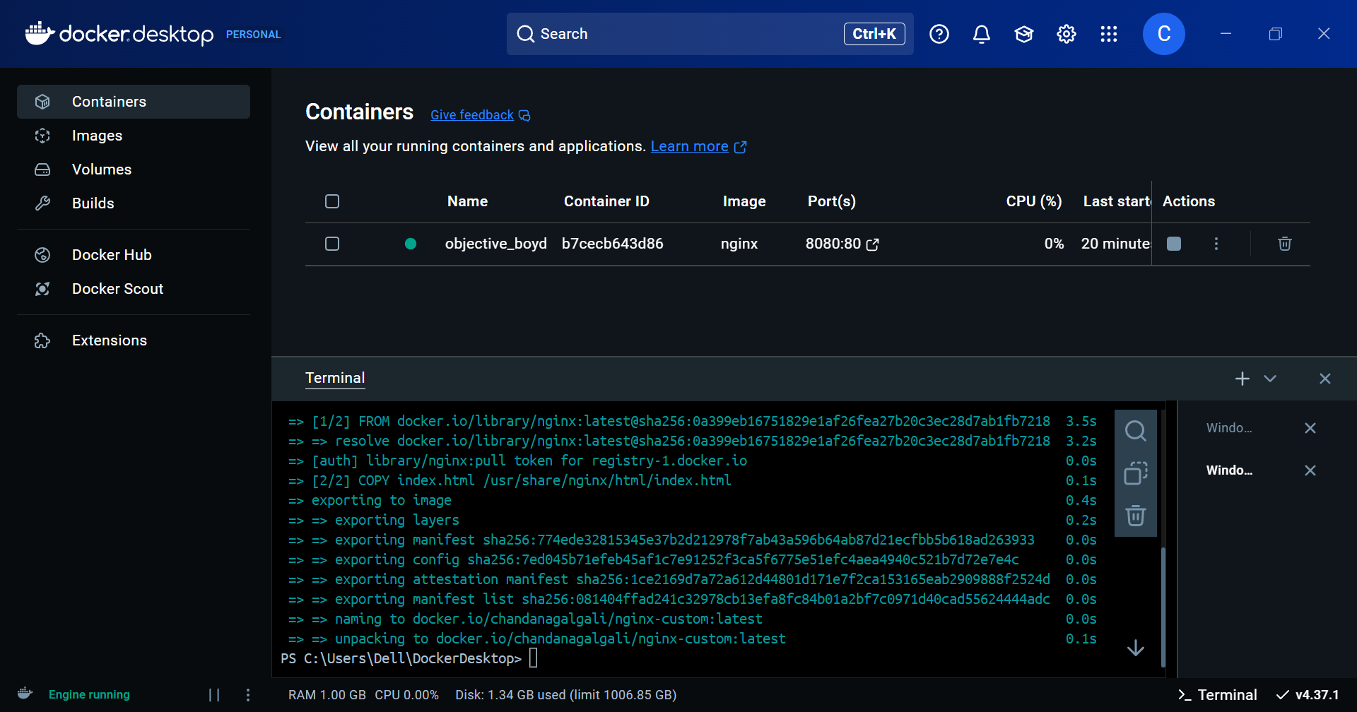

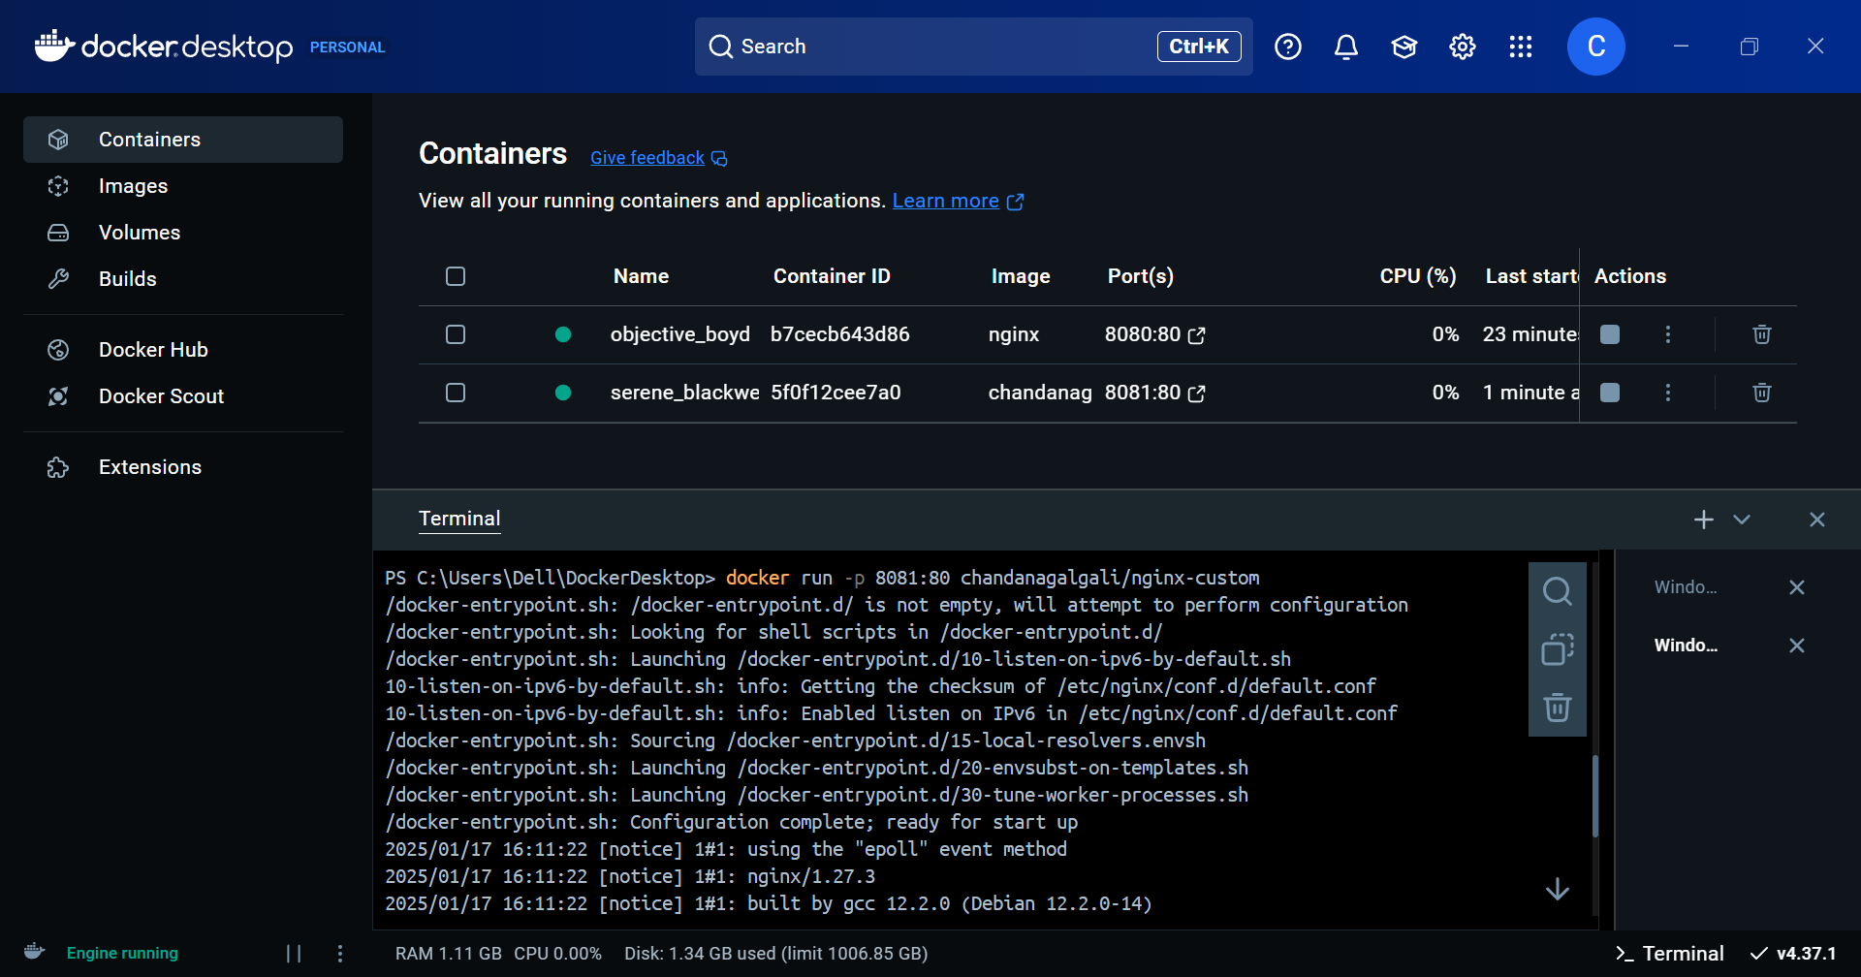

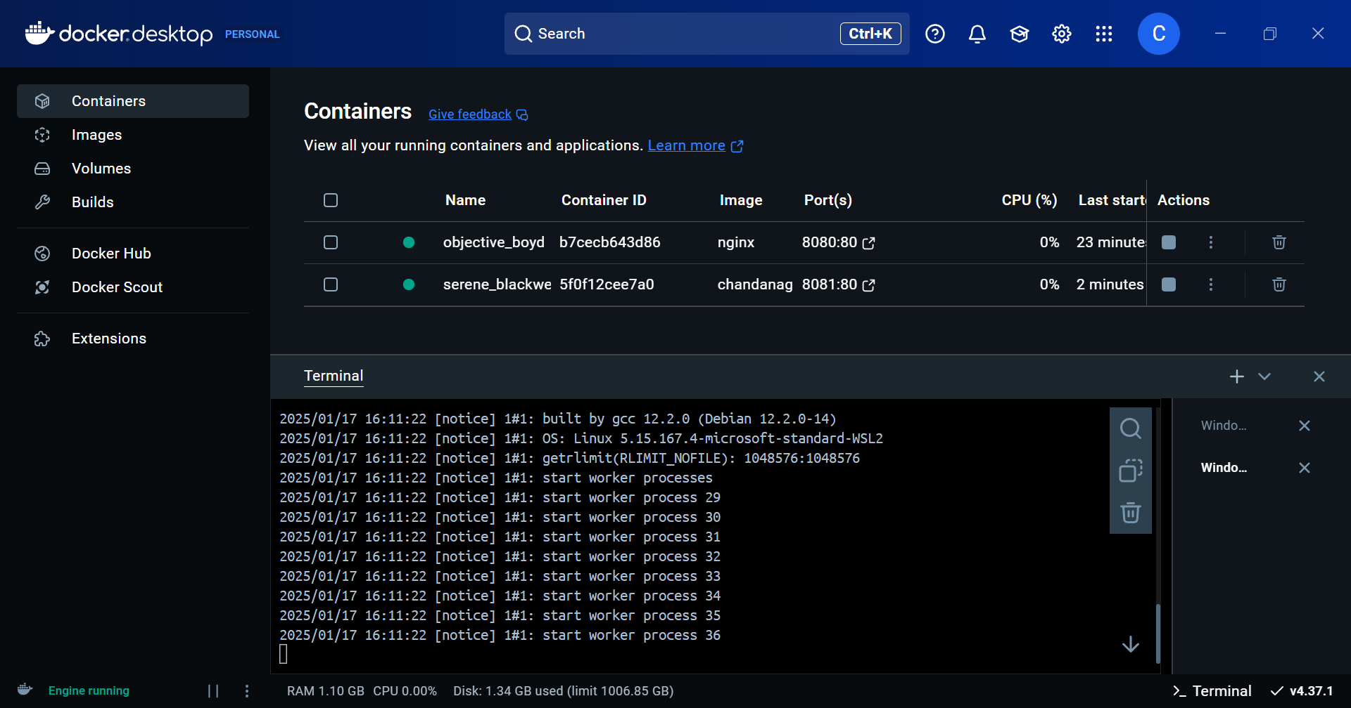

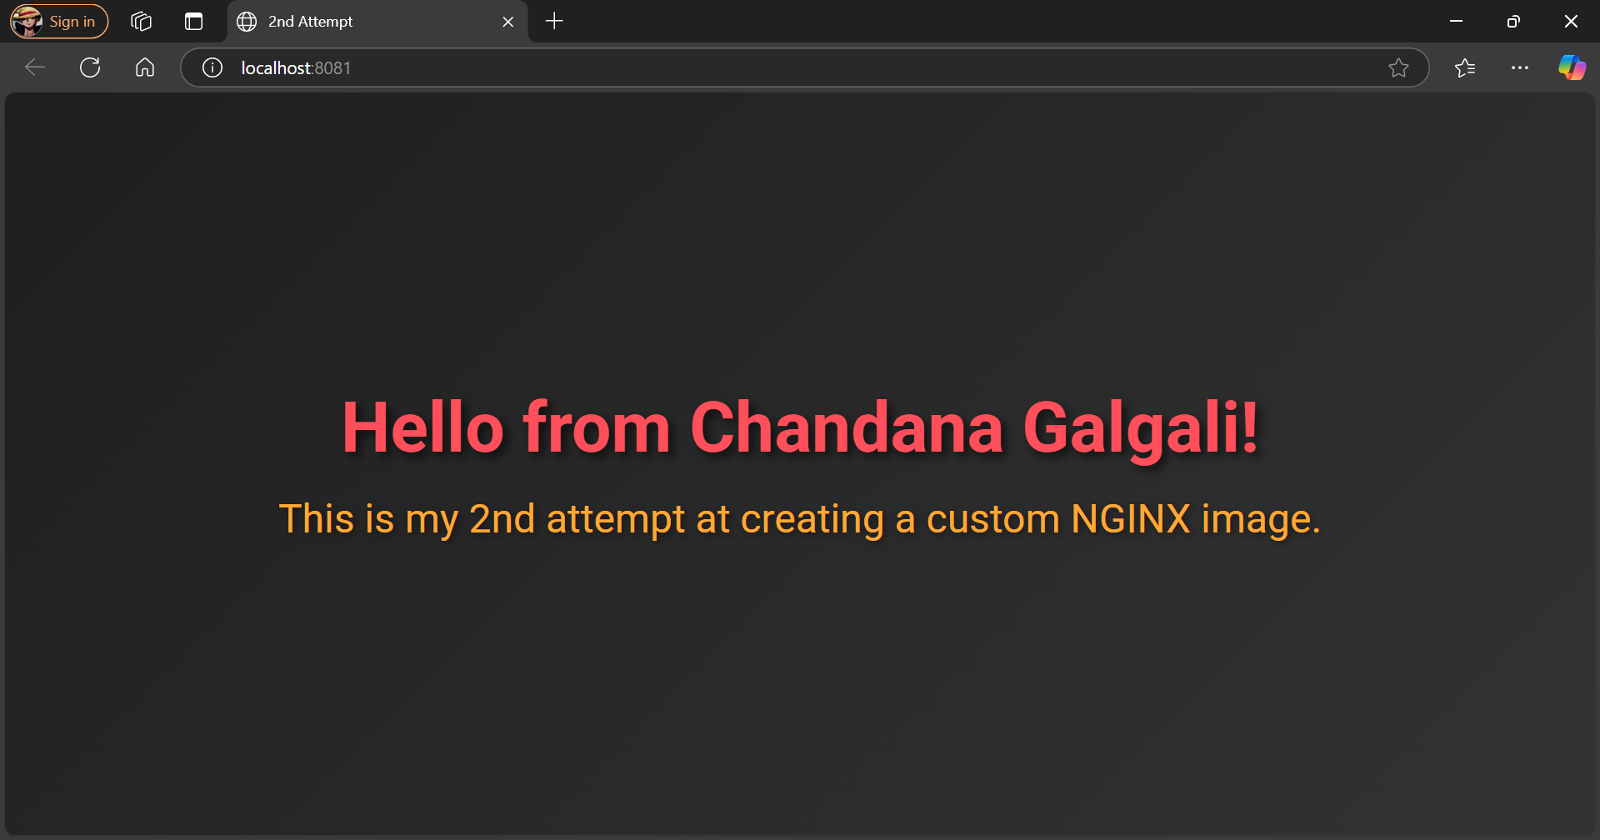

**Push NGINX Image to Docker Hub**

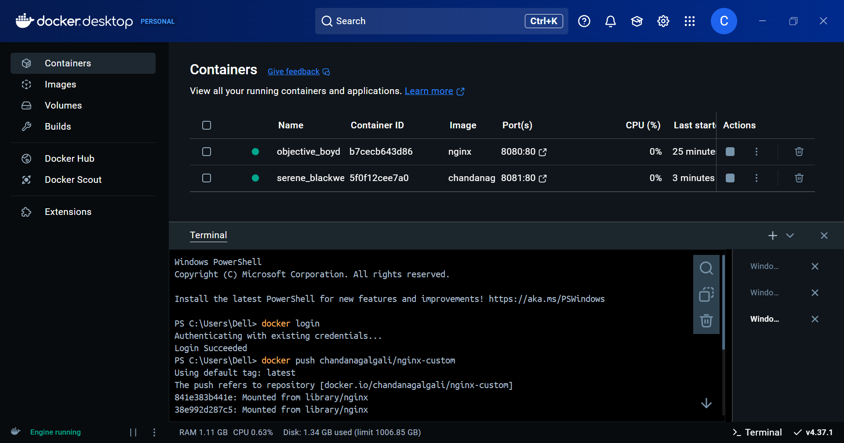

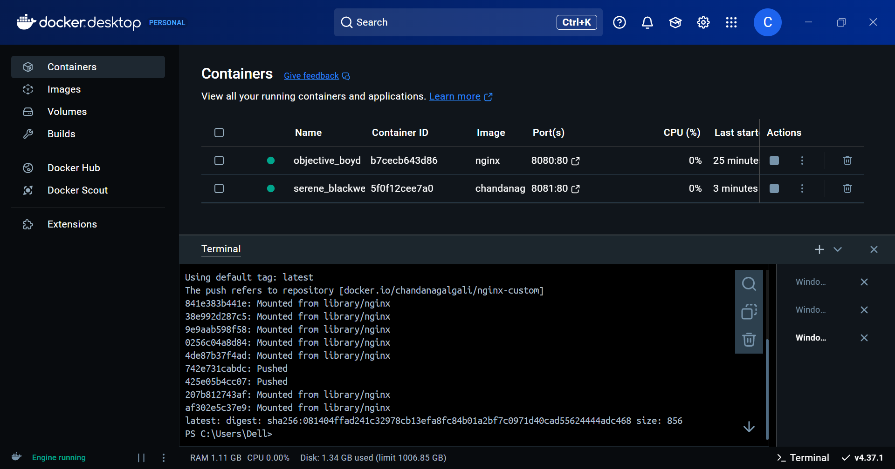

**Repeat for Two Other Images**

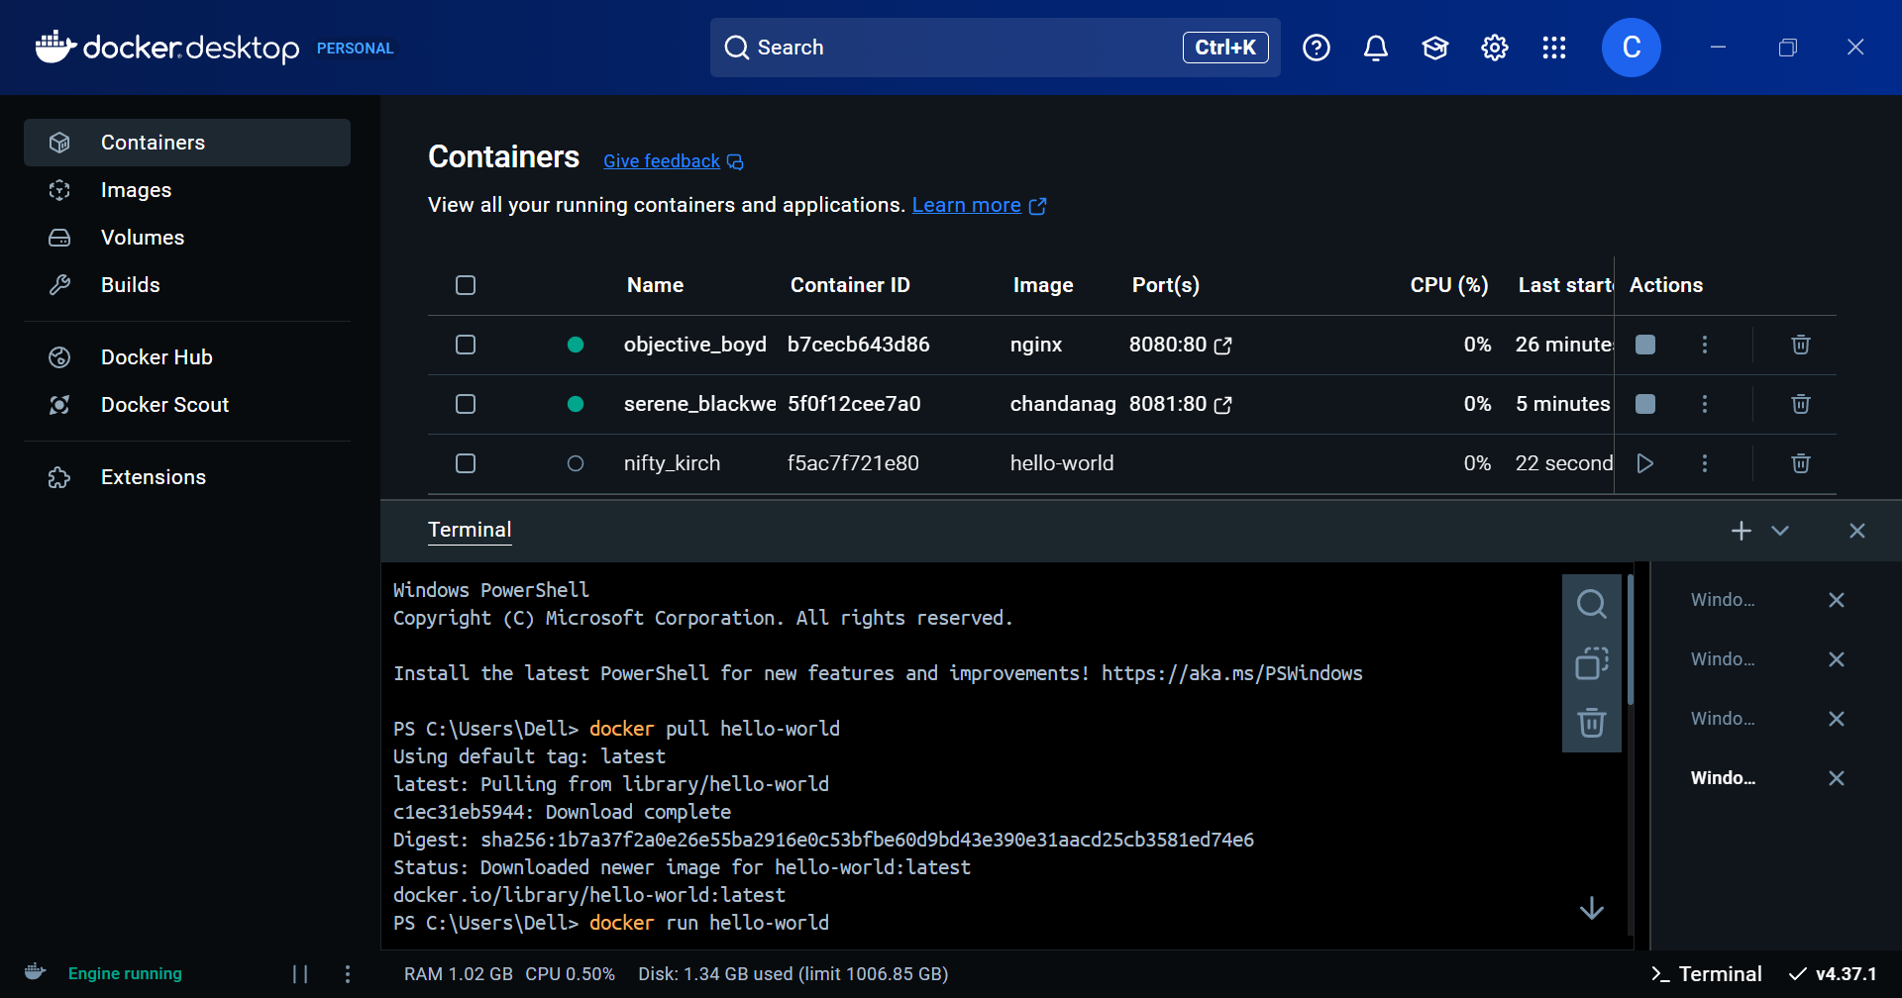

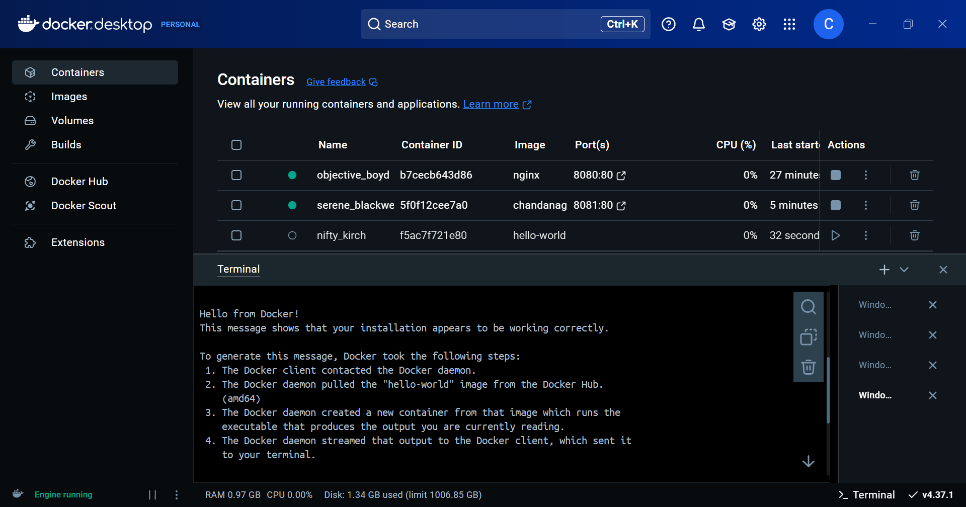

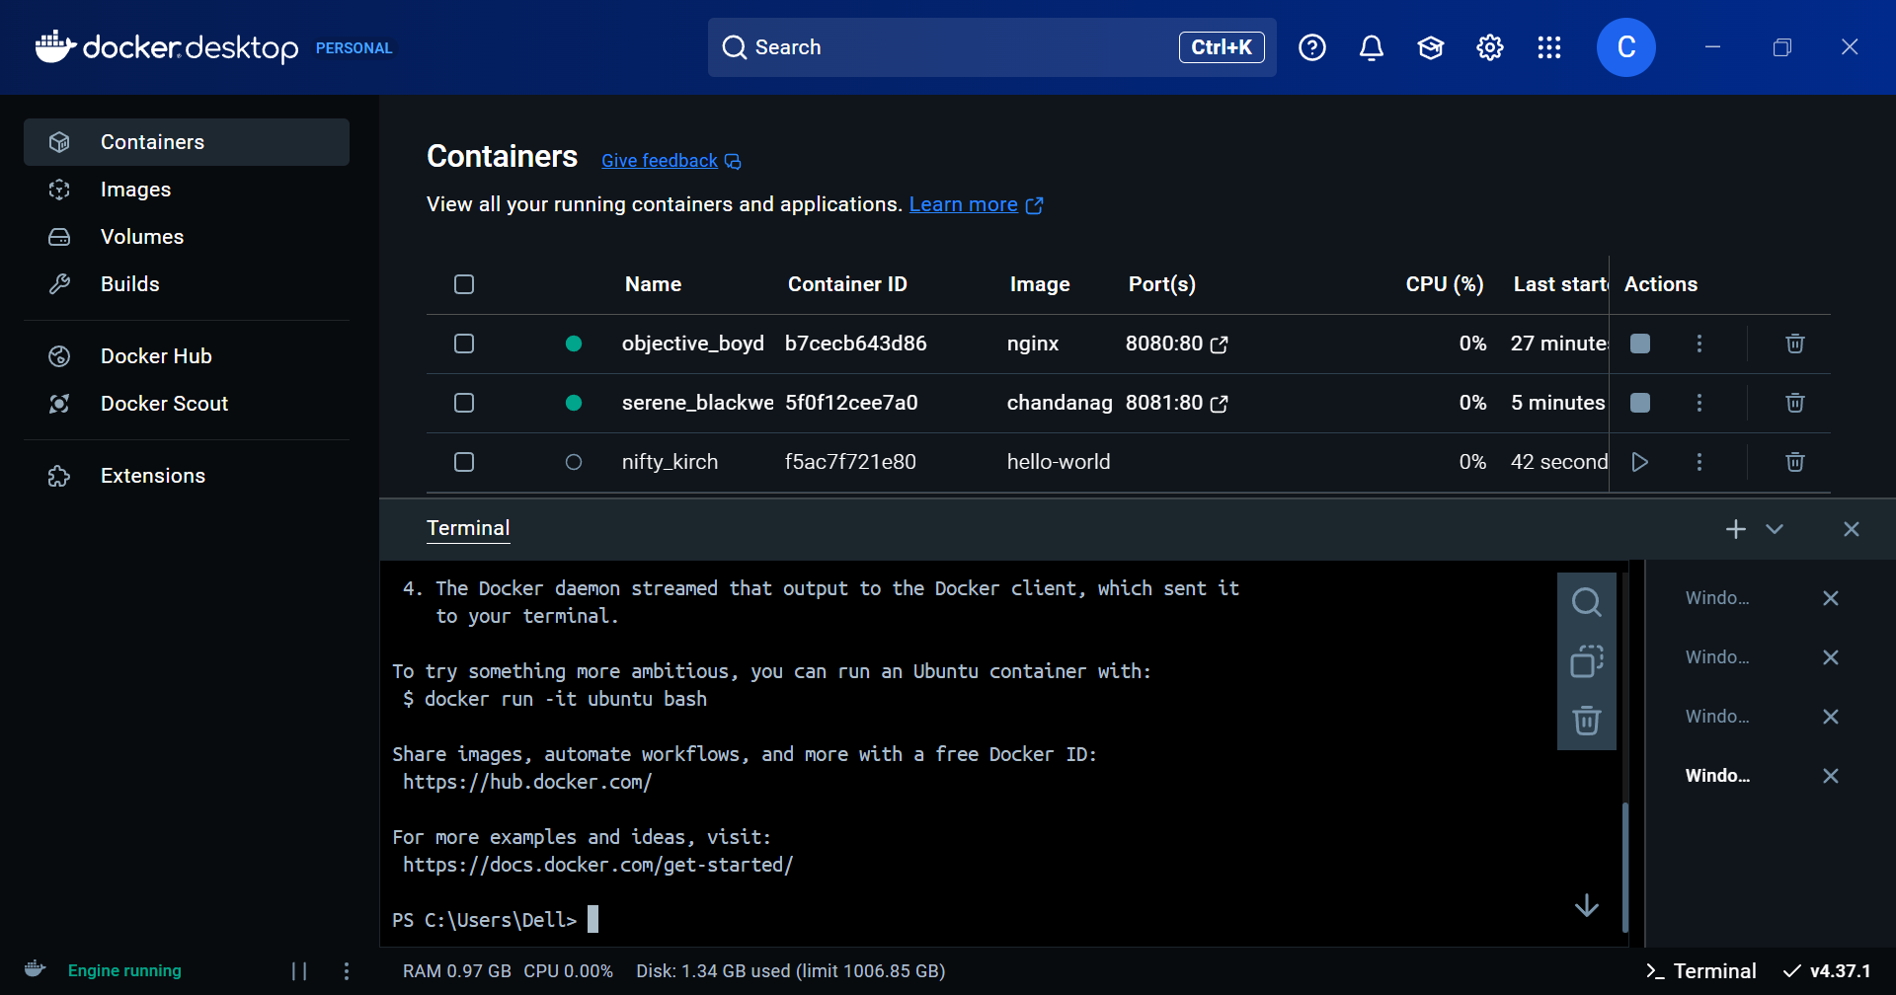

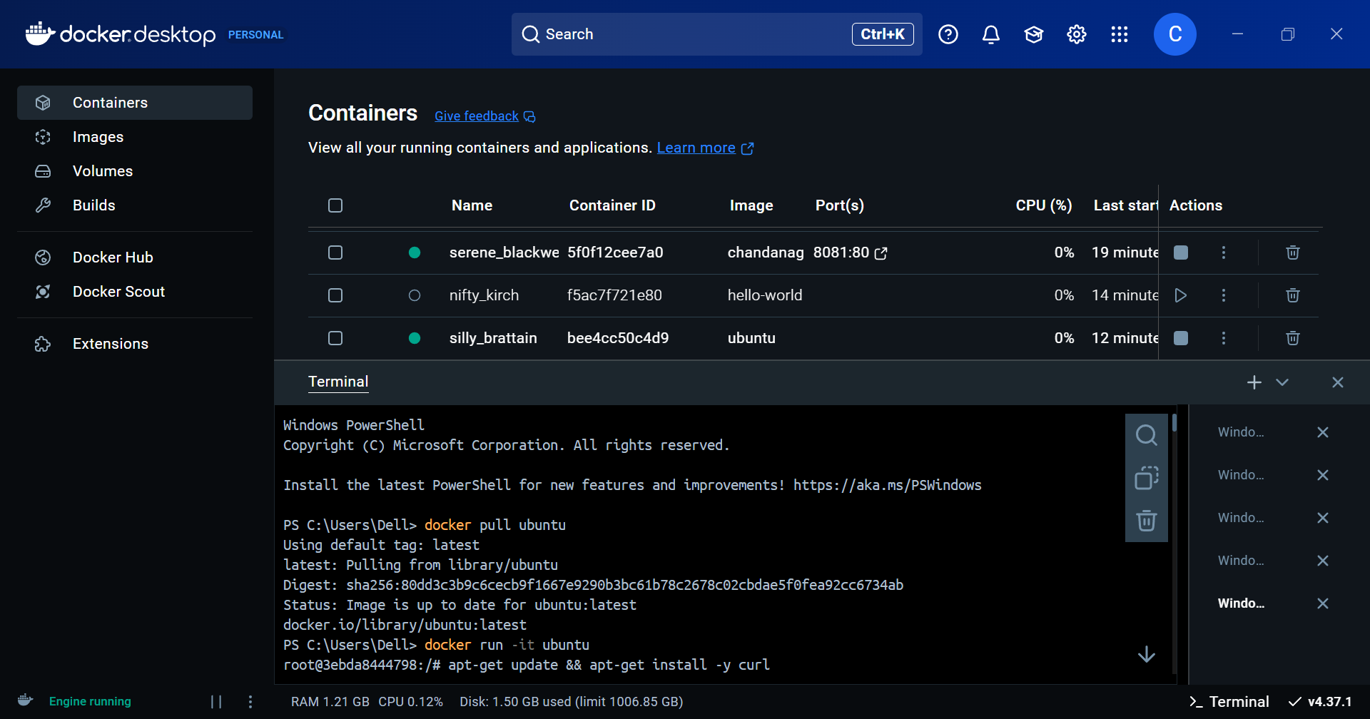

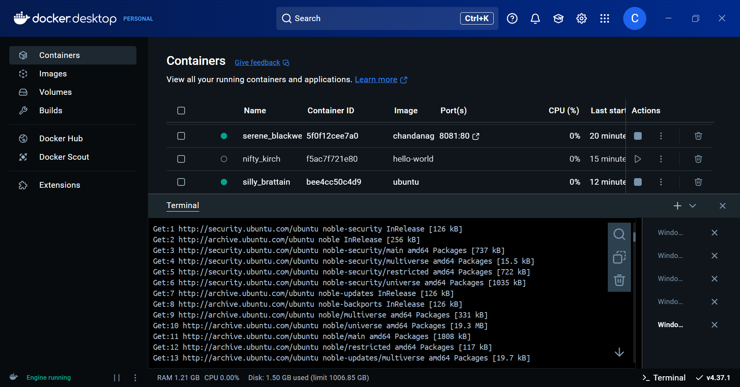

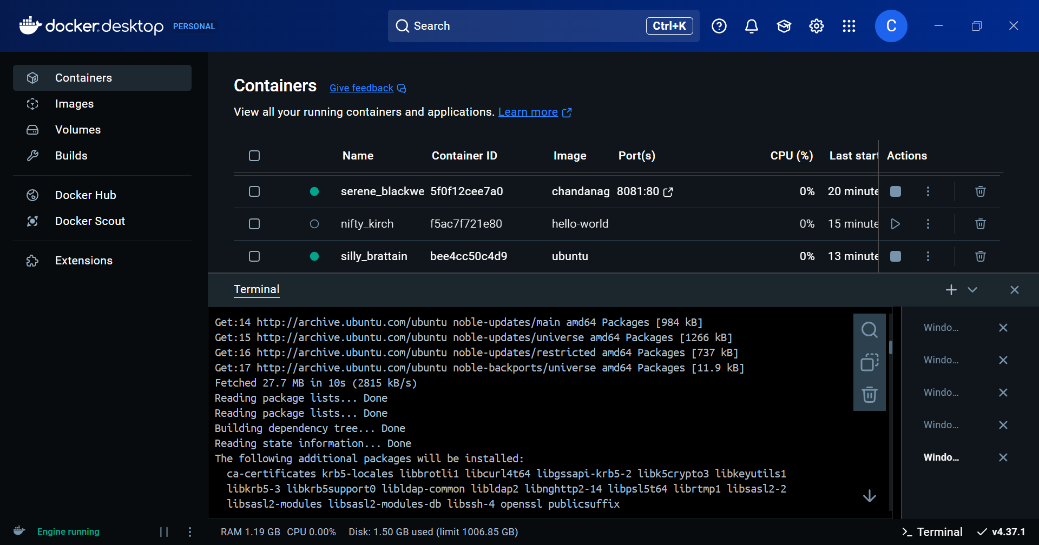

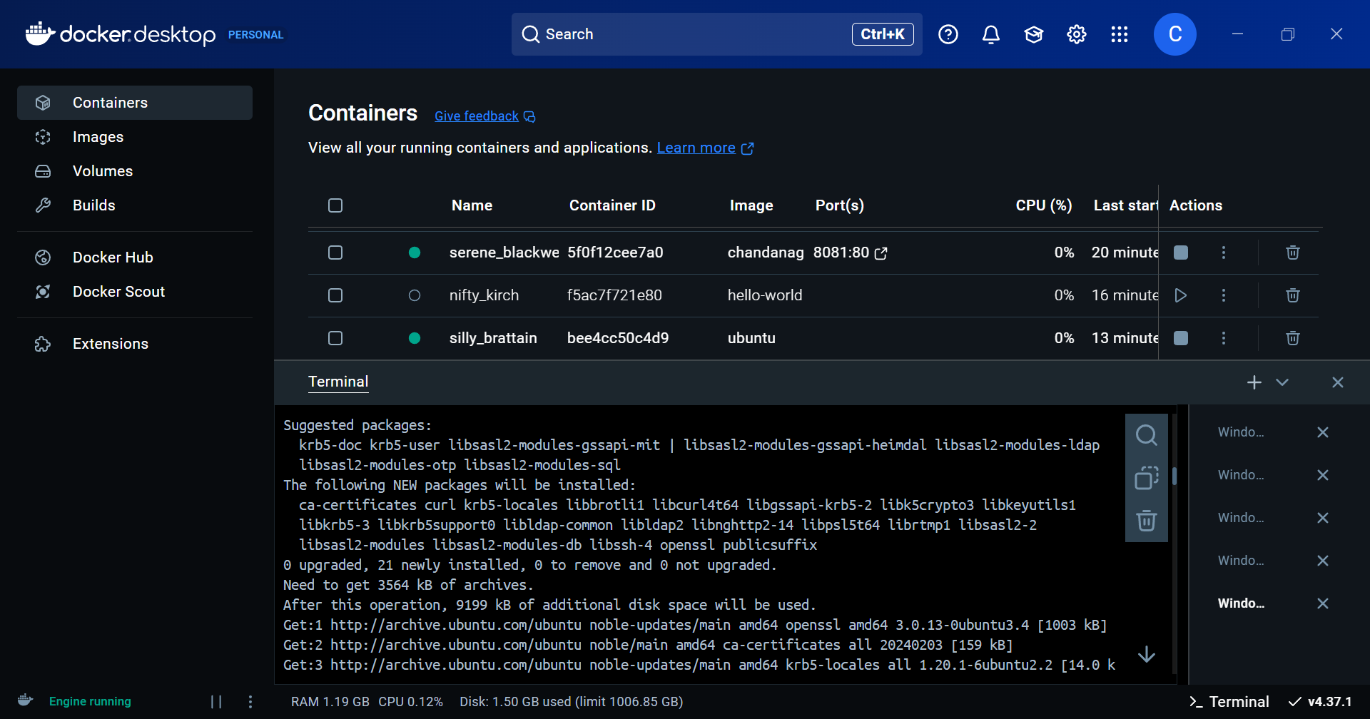

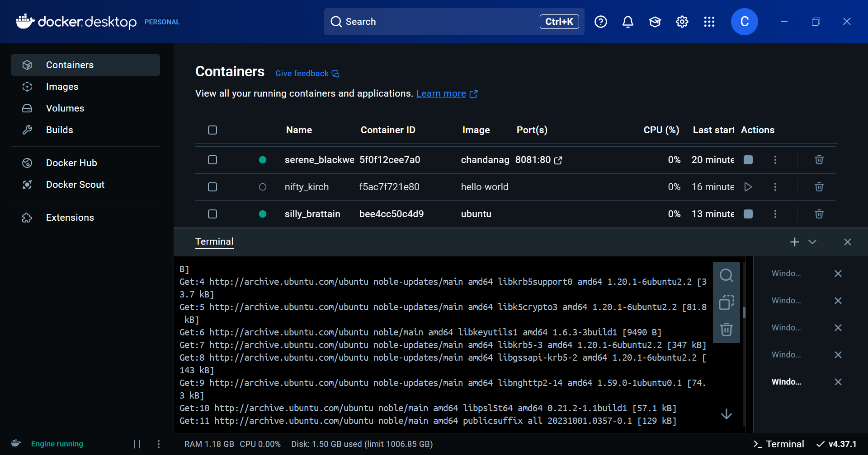

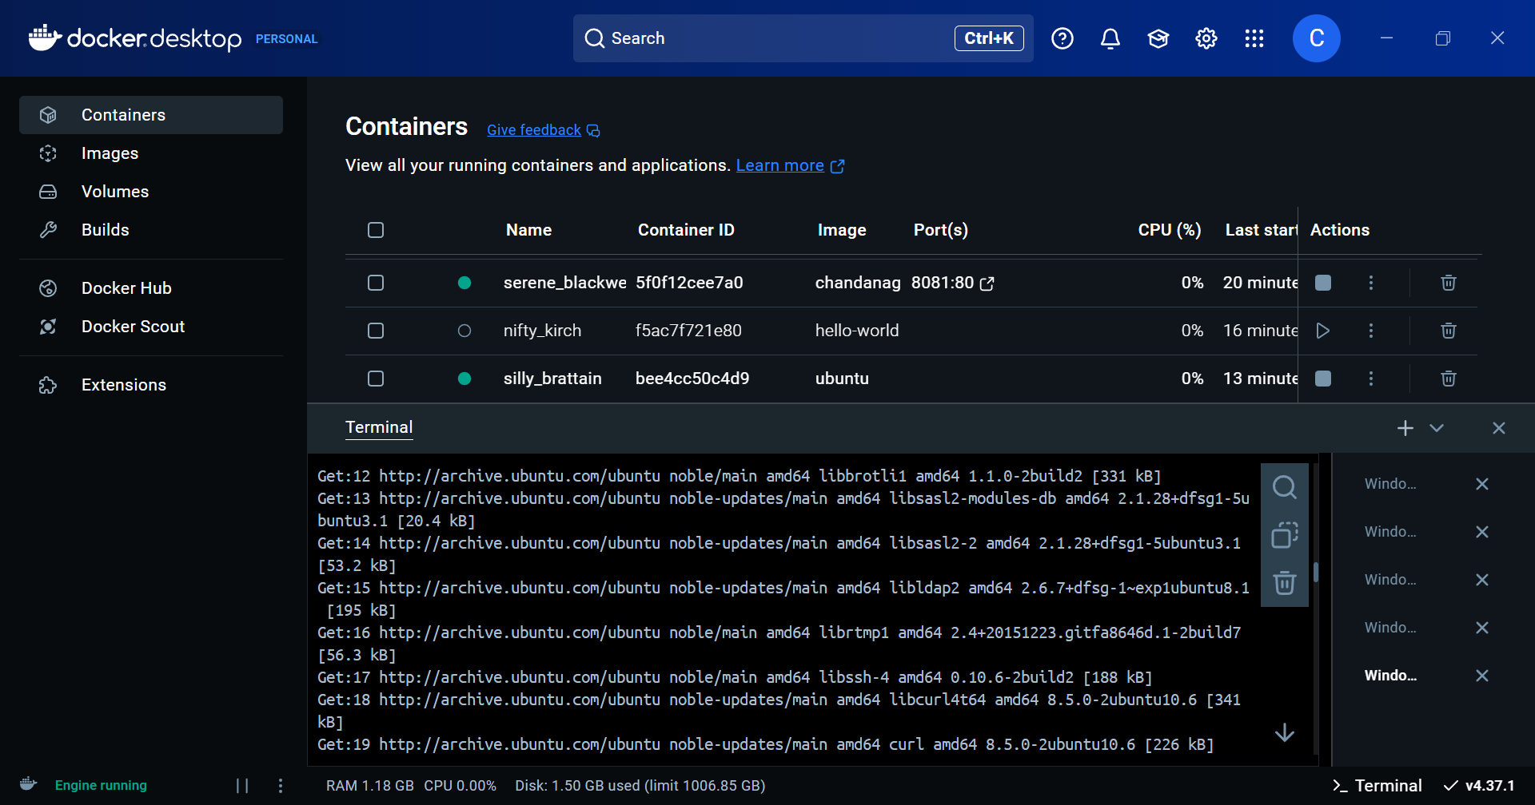

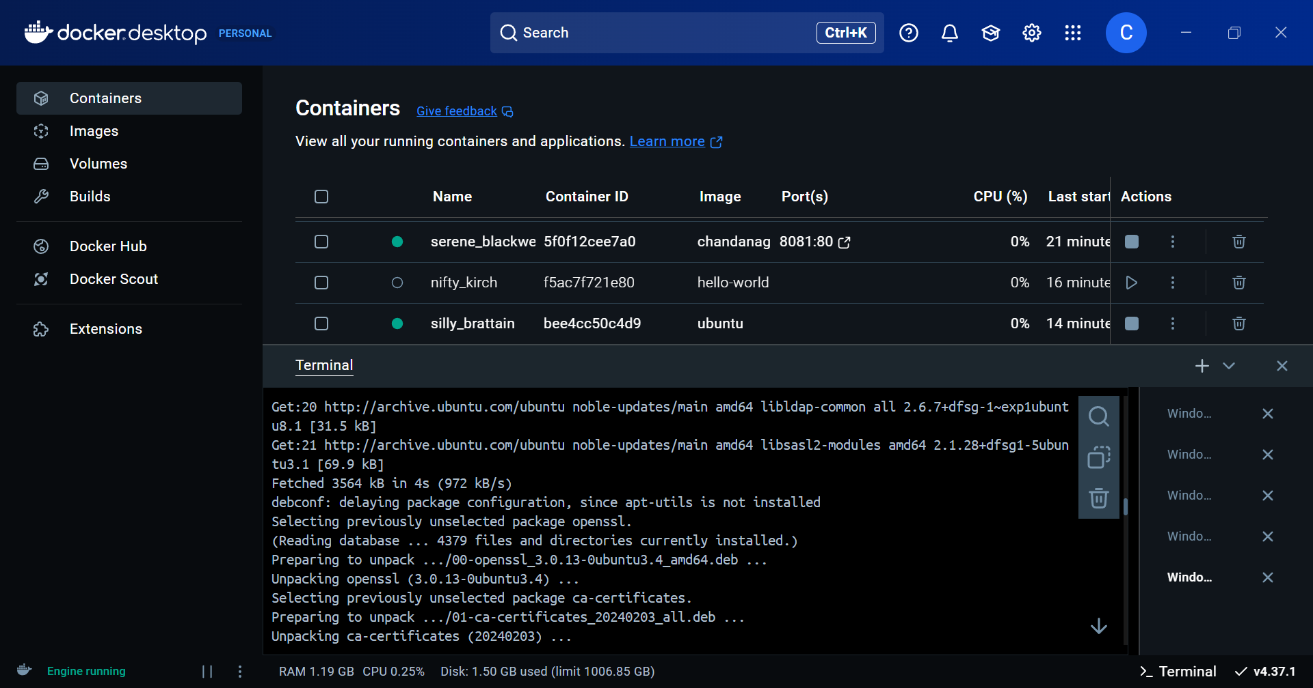

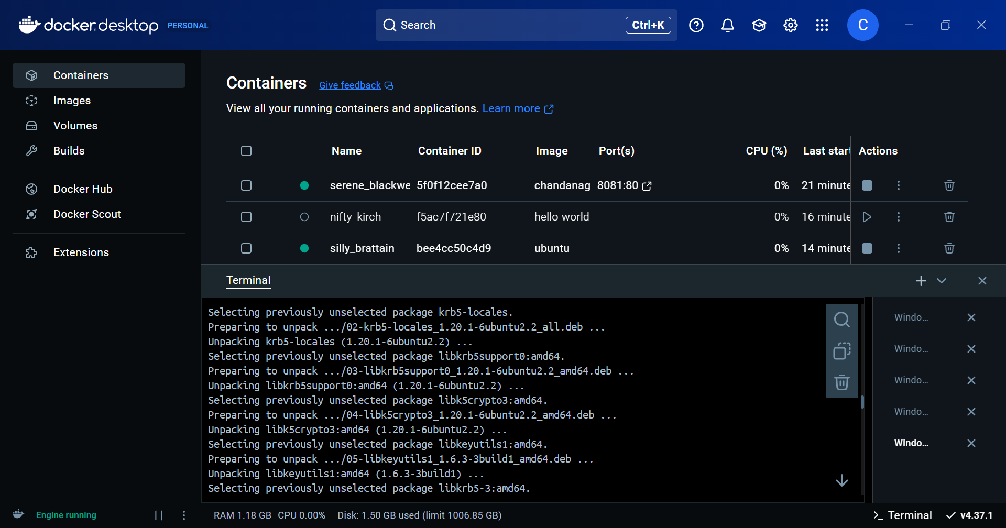

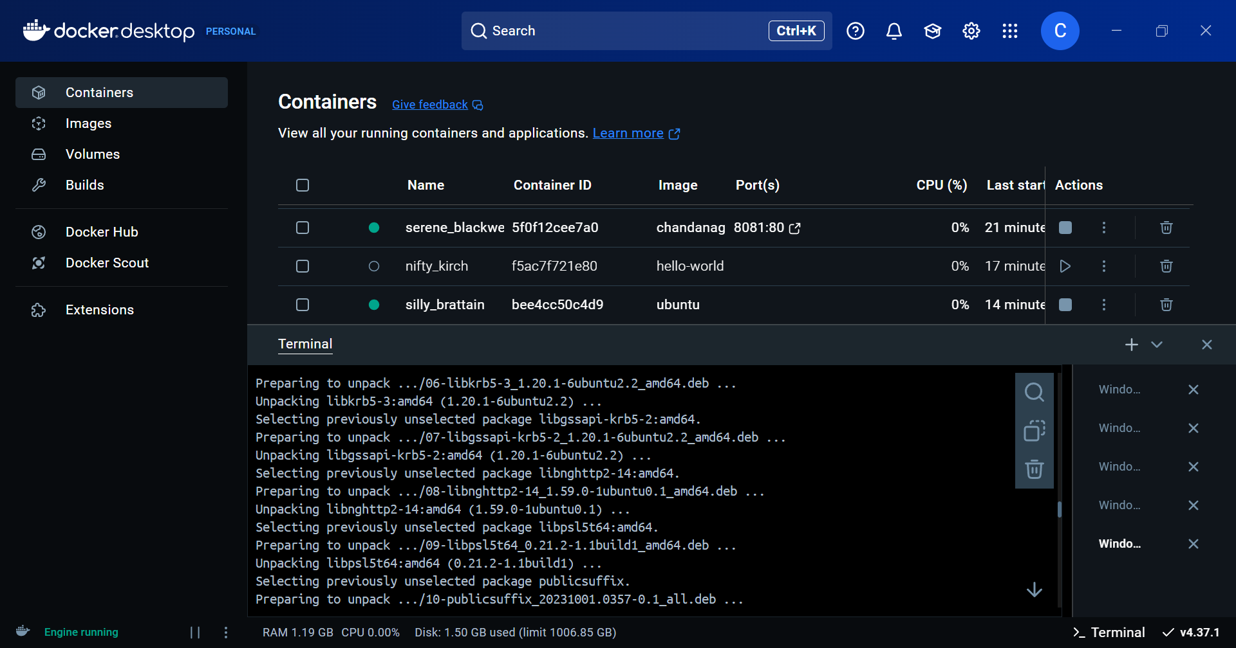

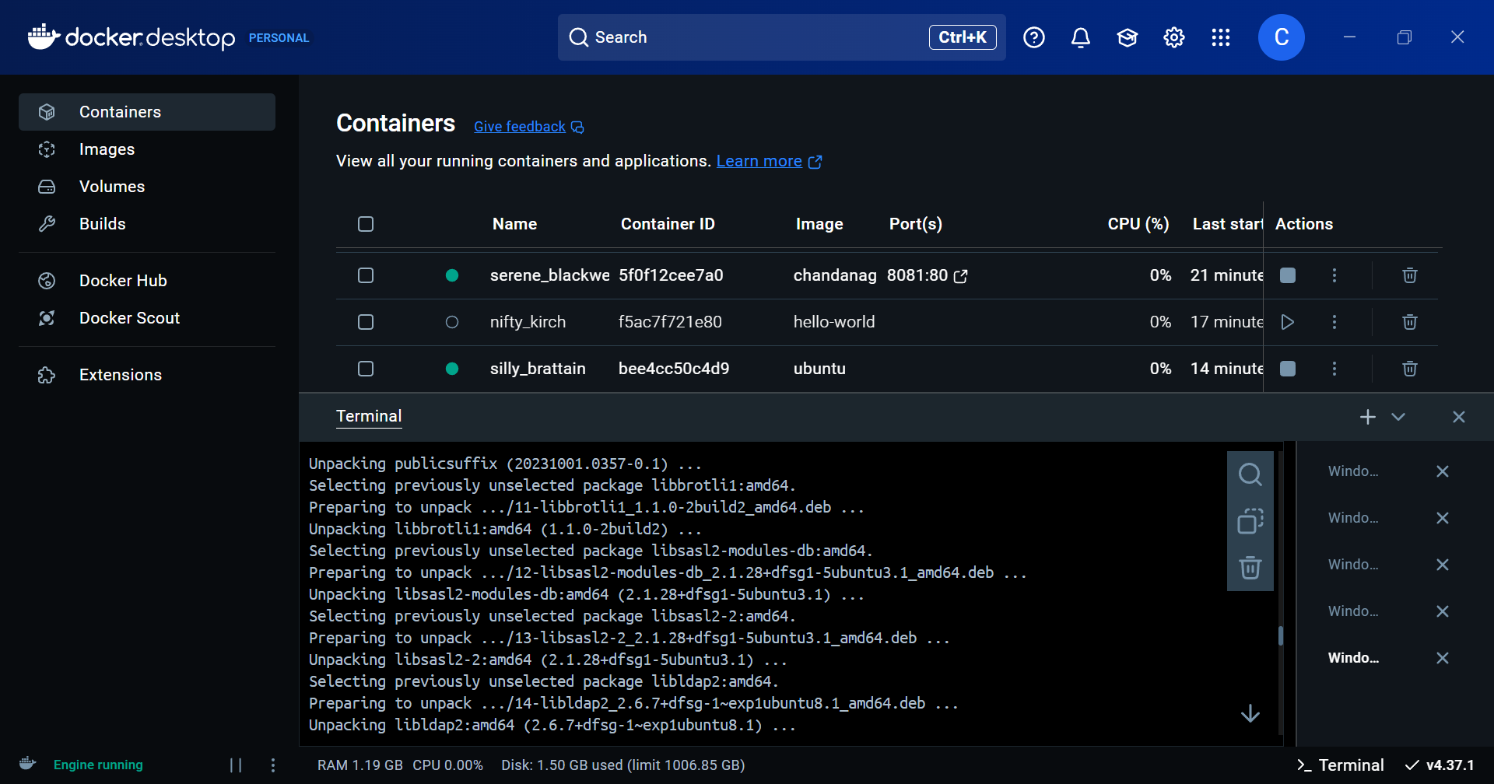

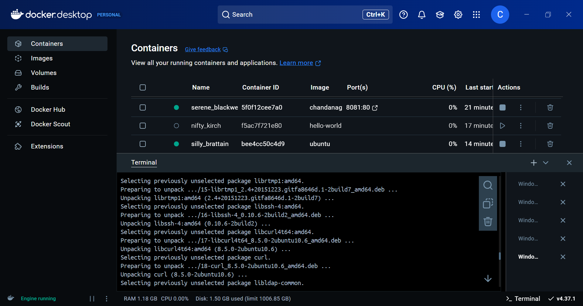

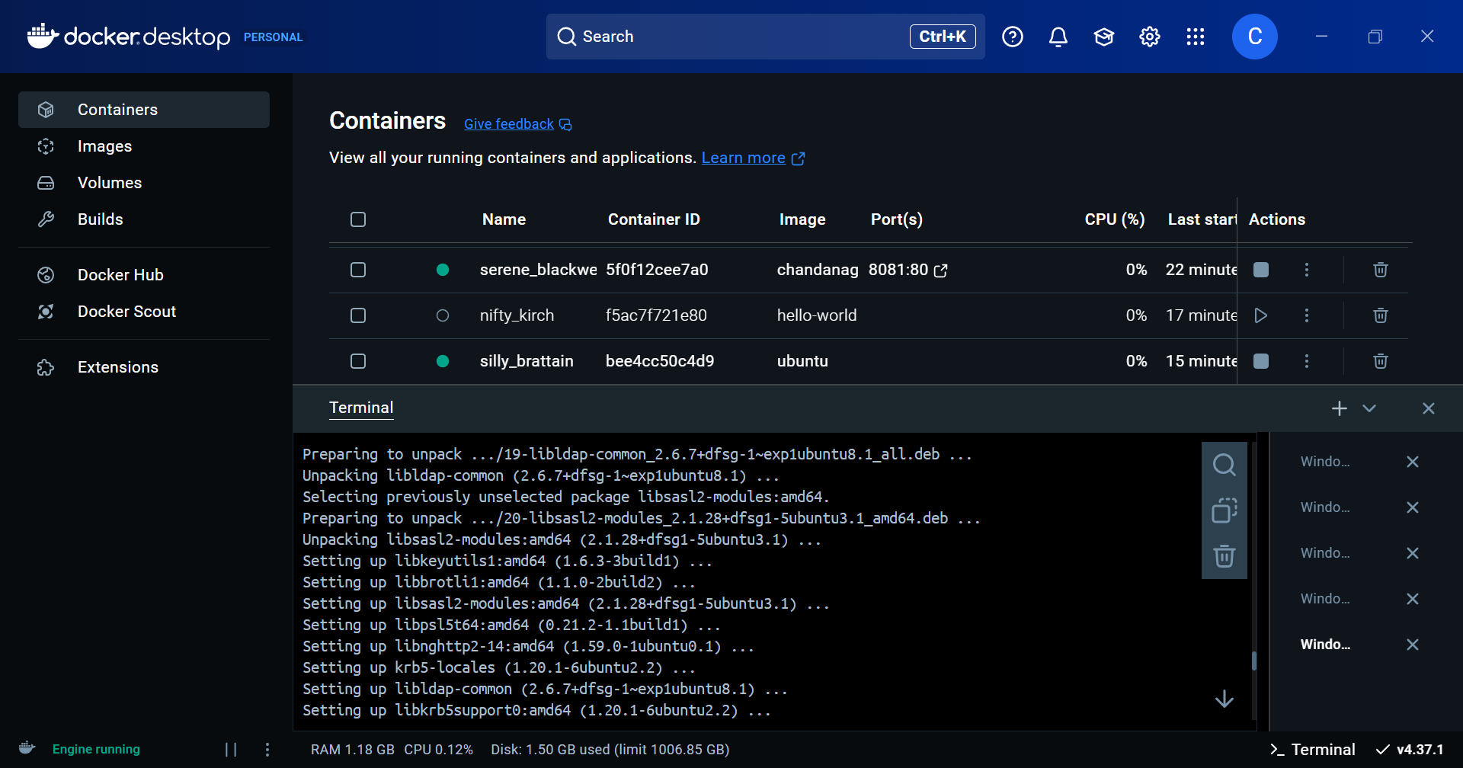

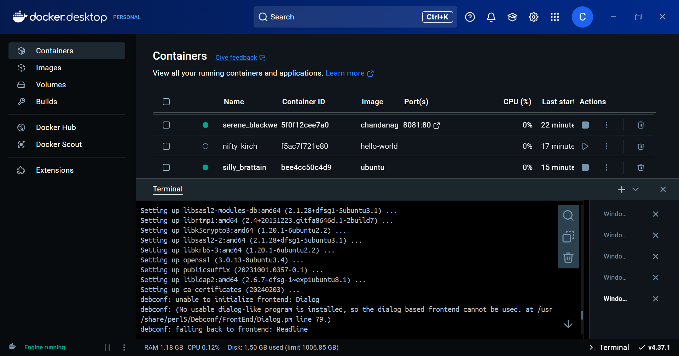

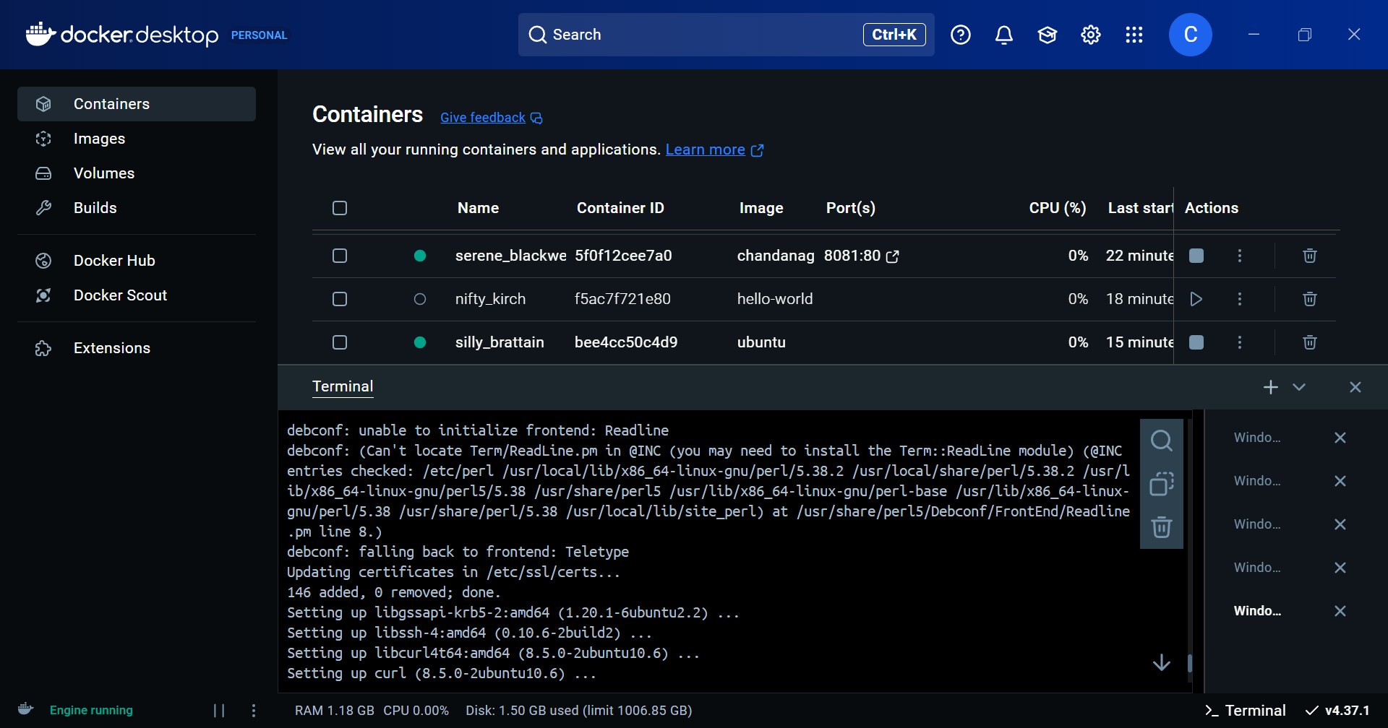

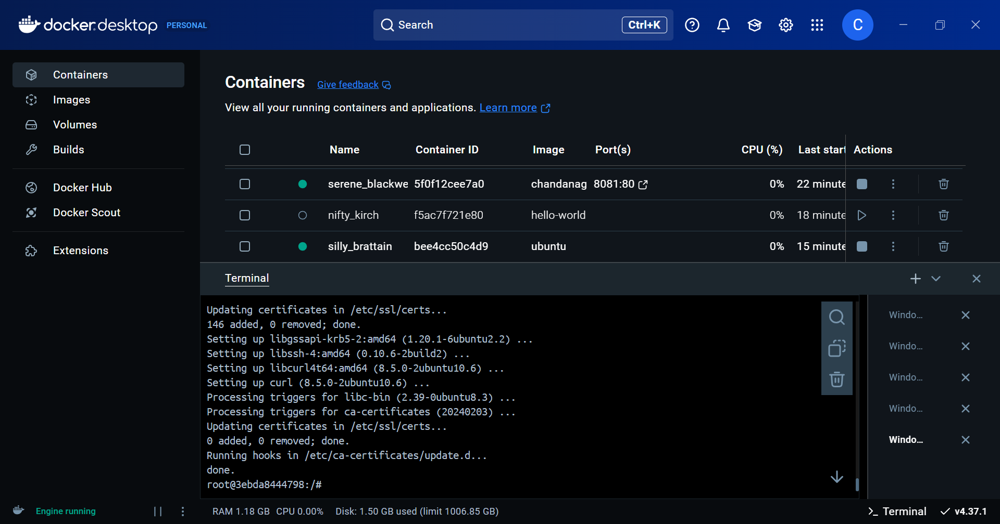

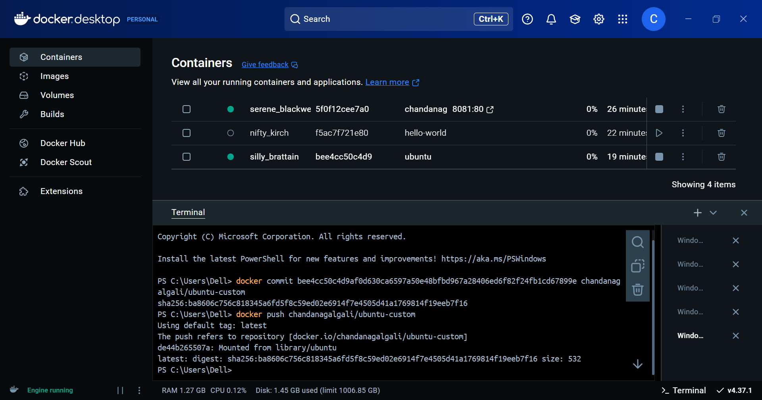

**Verify Docker Hub Repository**

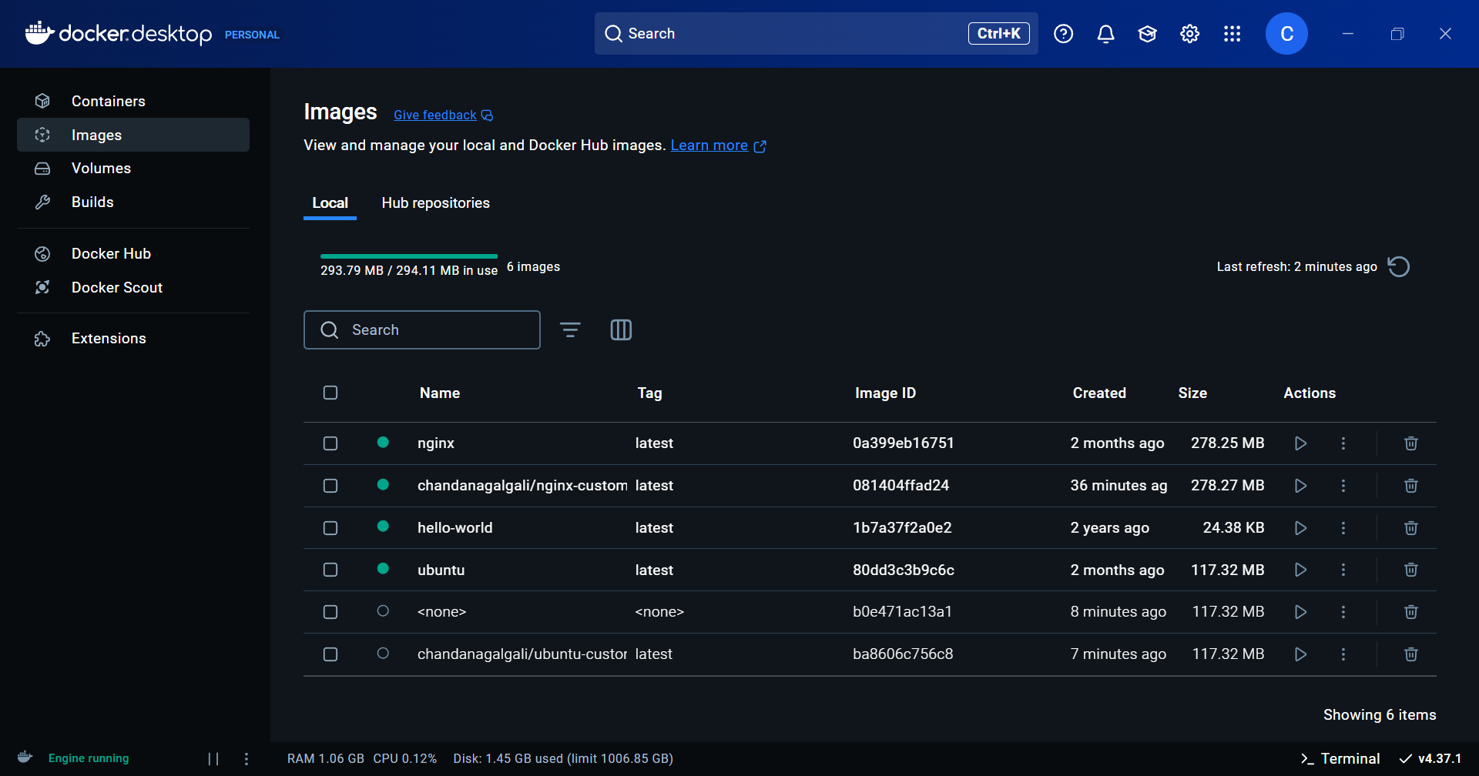

**10 Docker Commands**

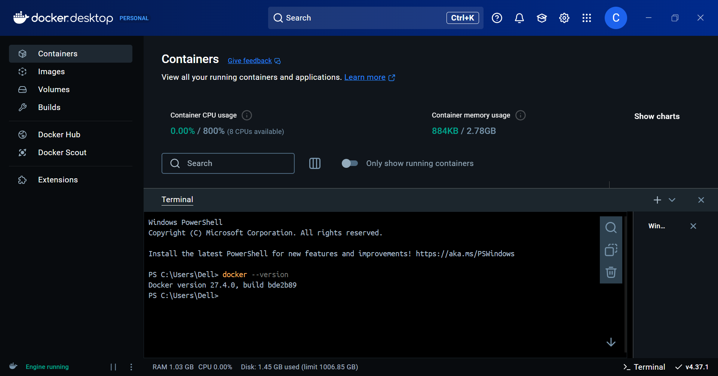

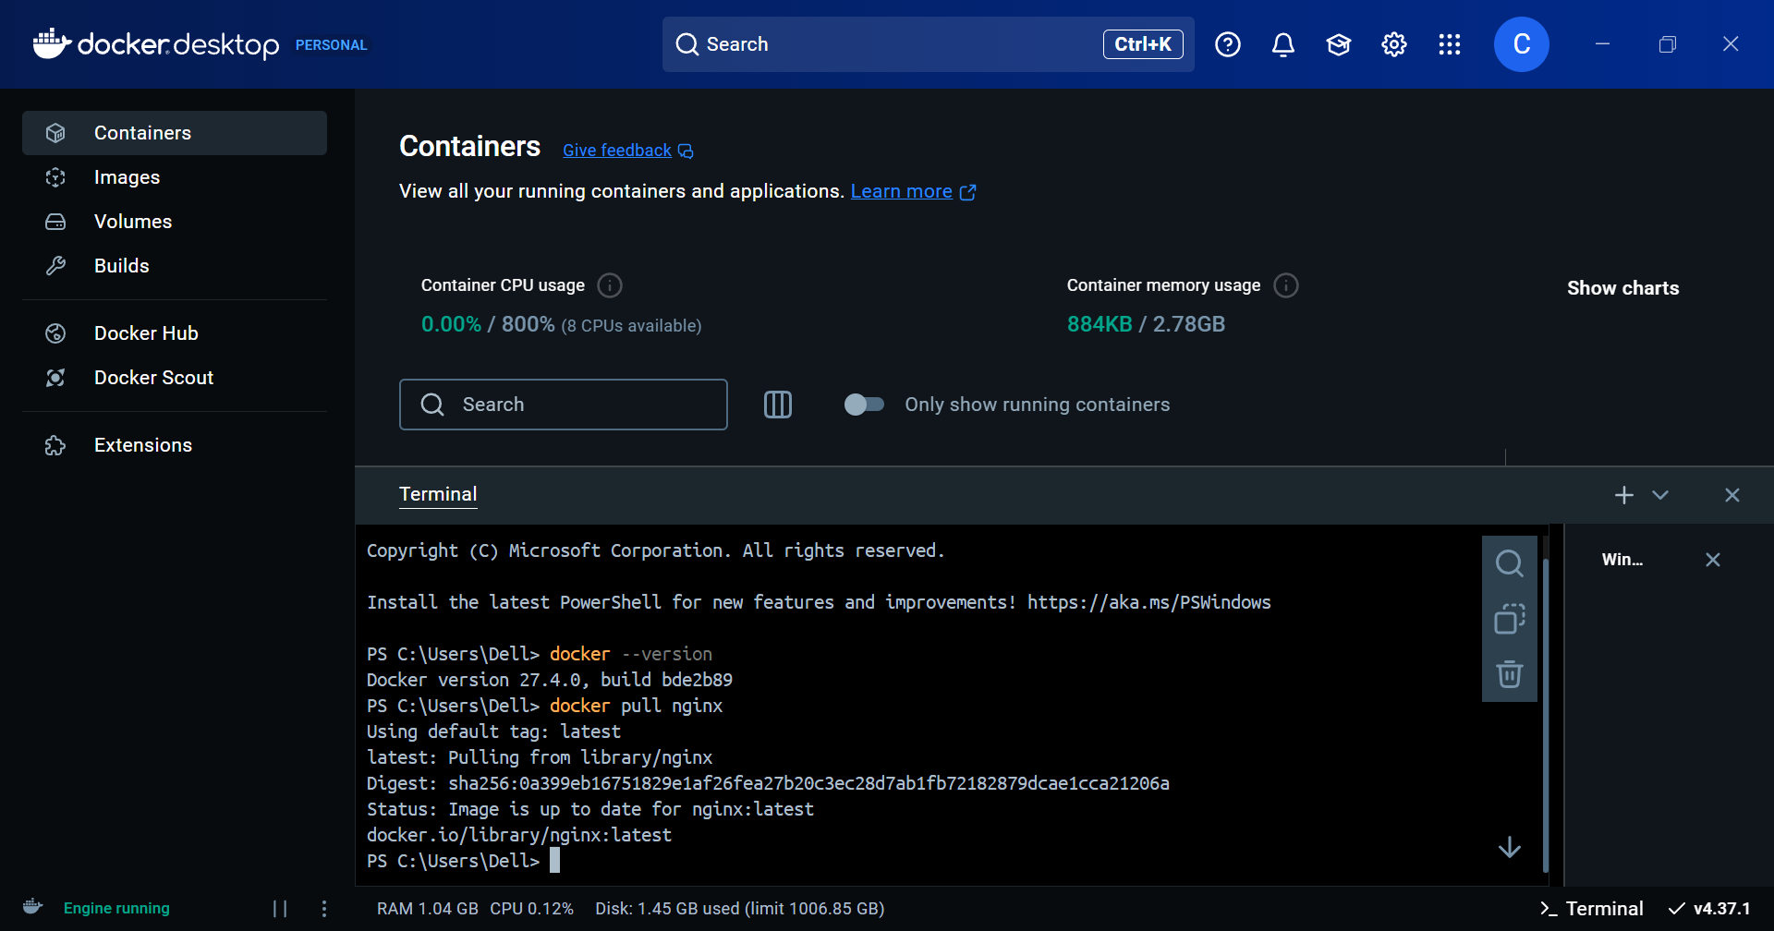

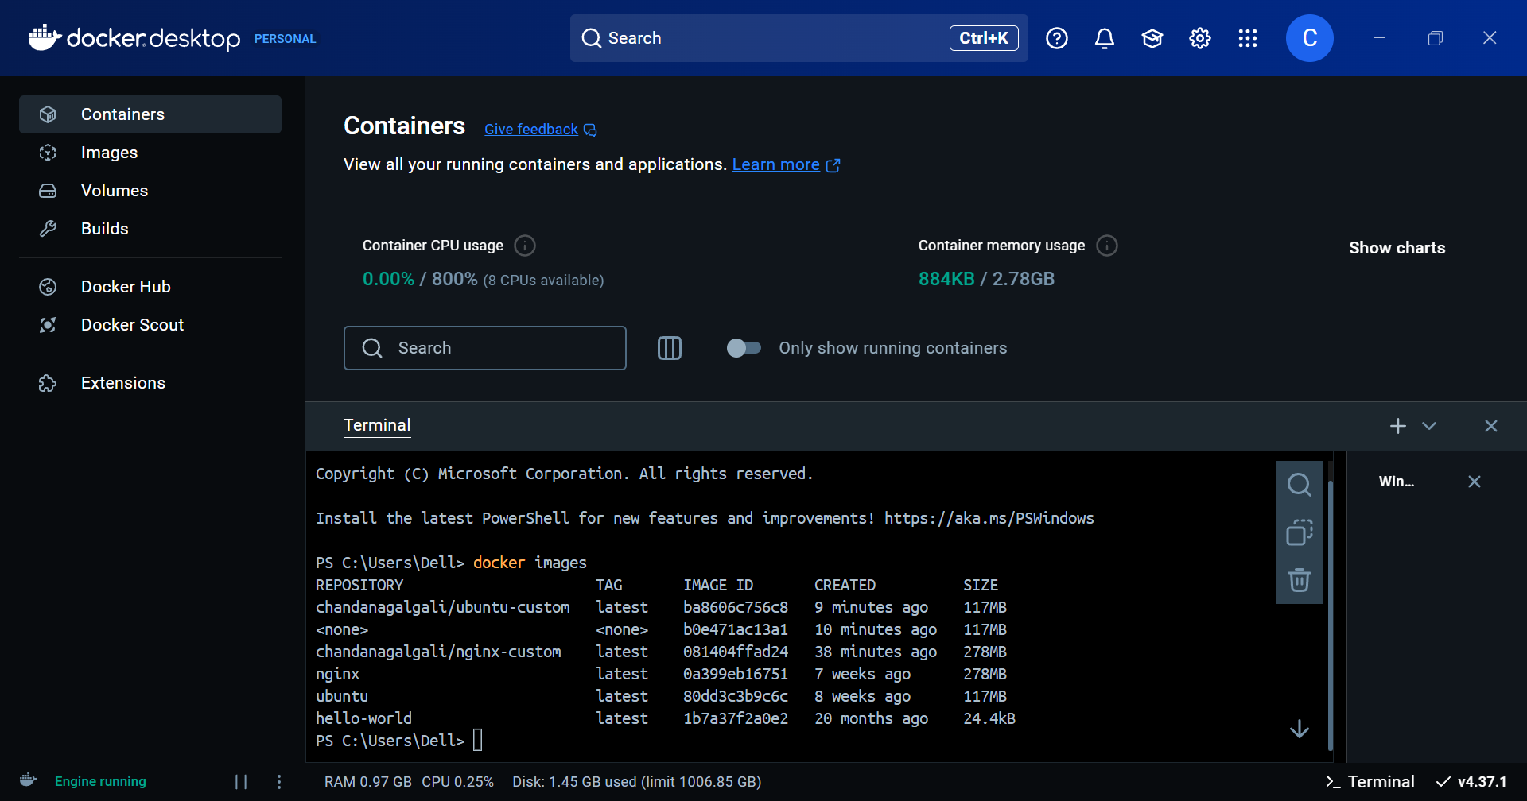

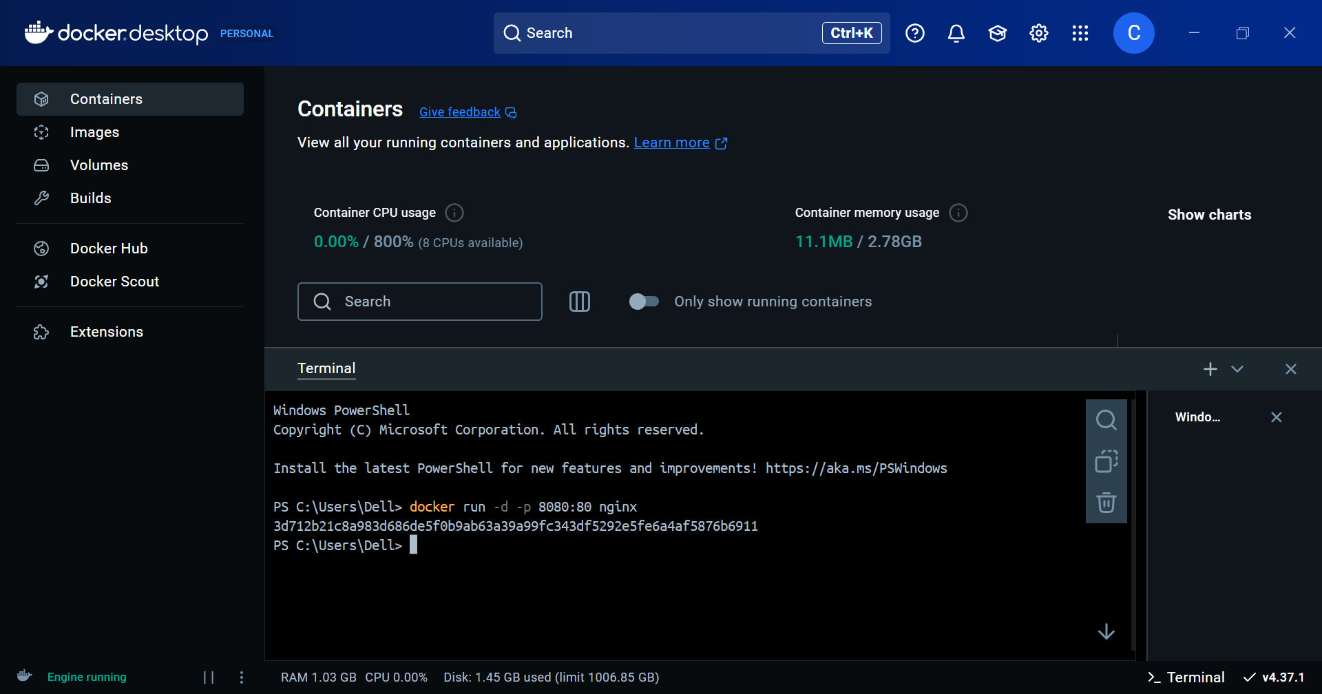

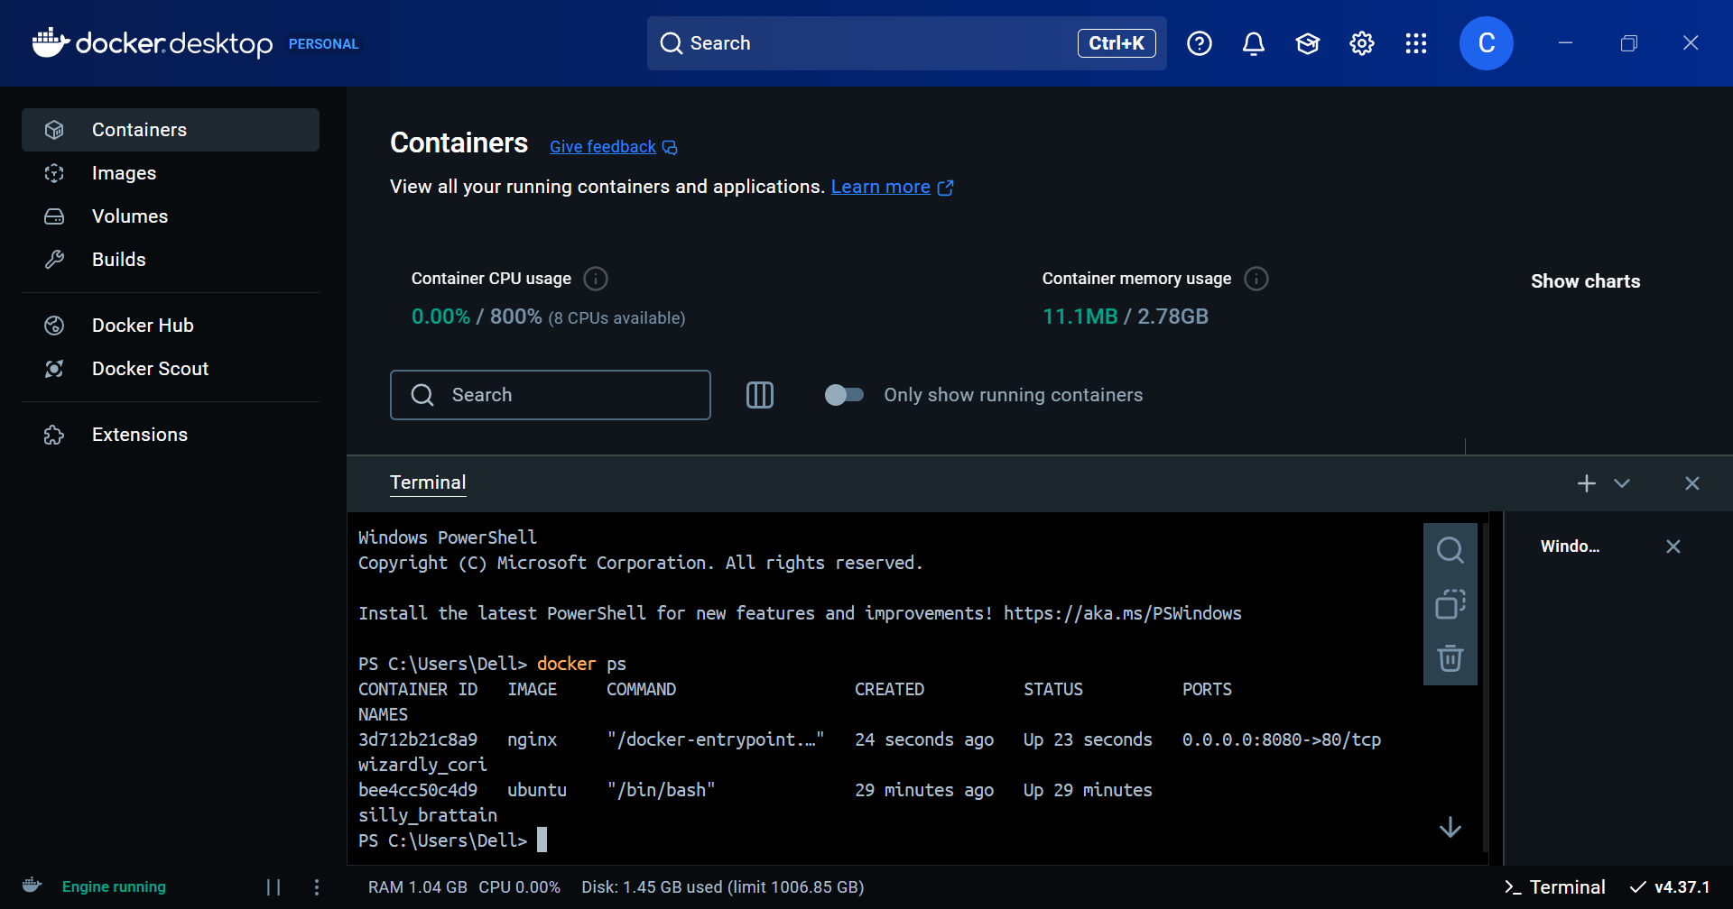

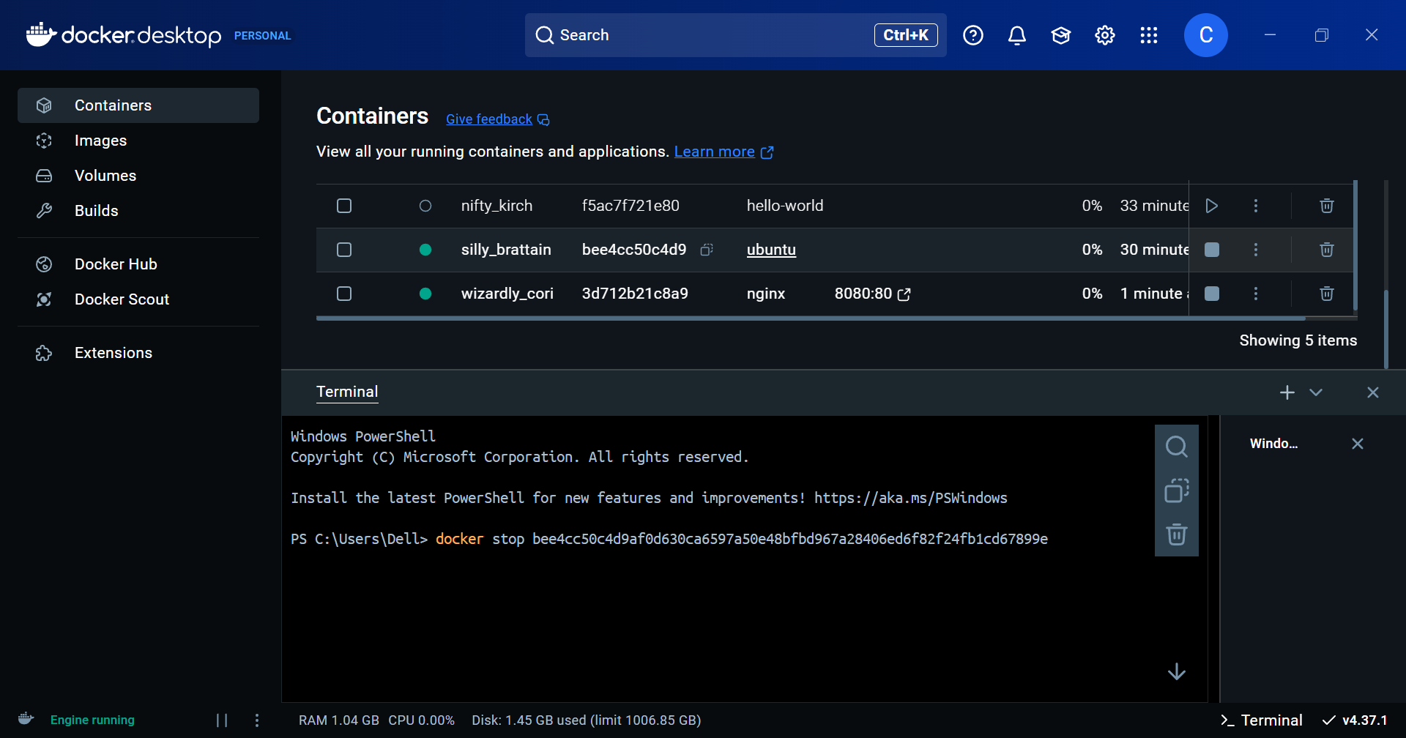

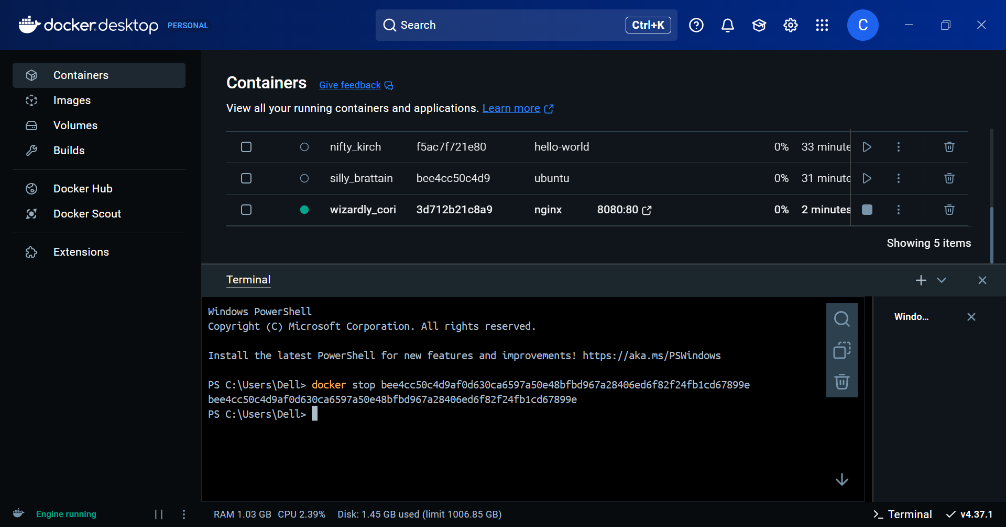

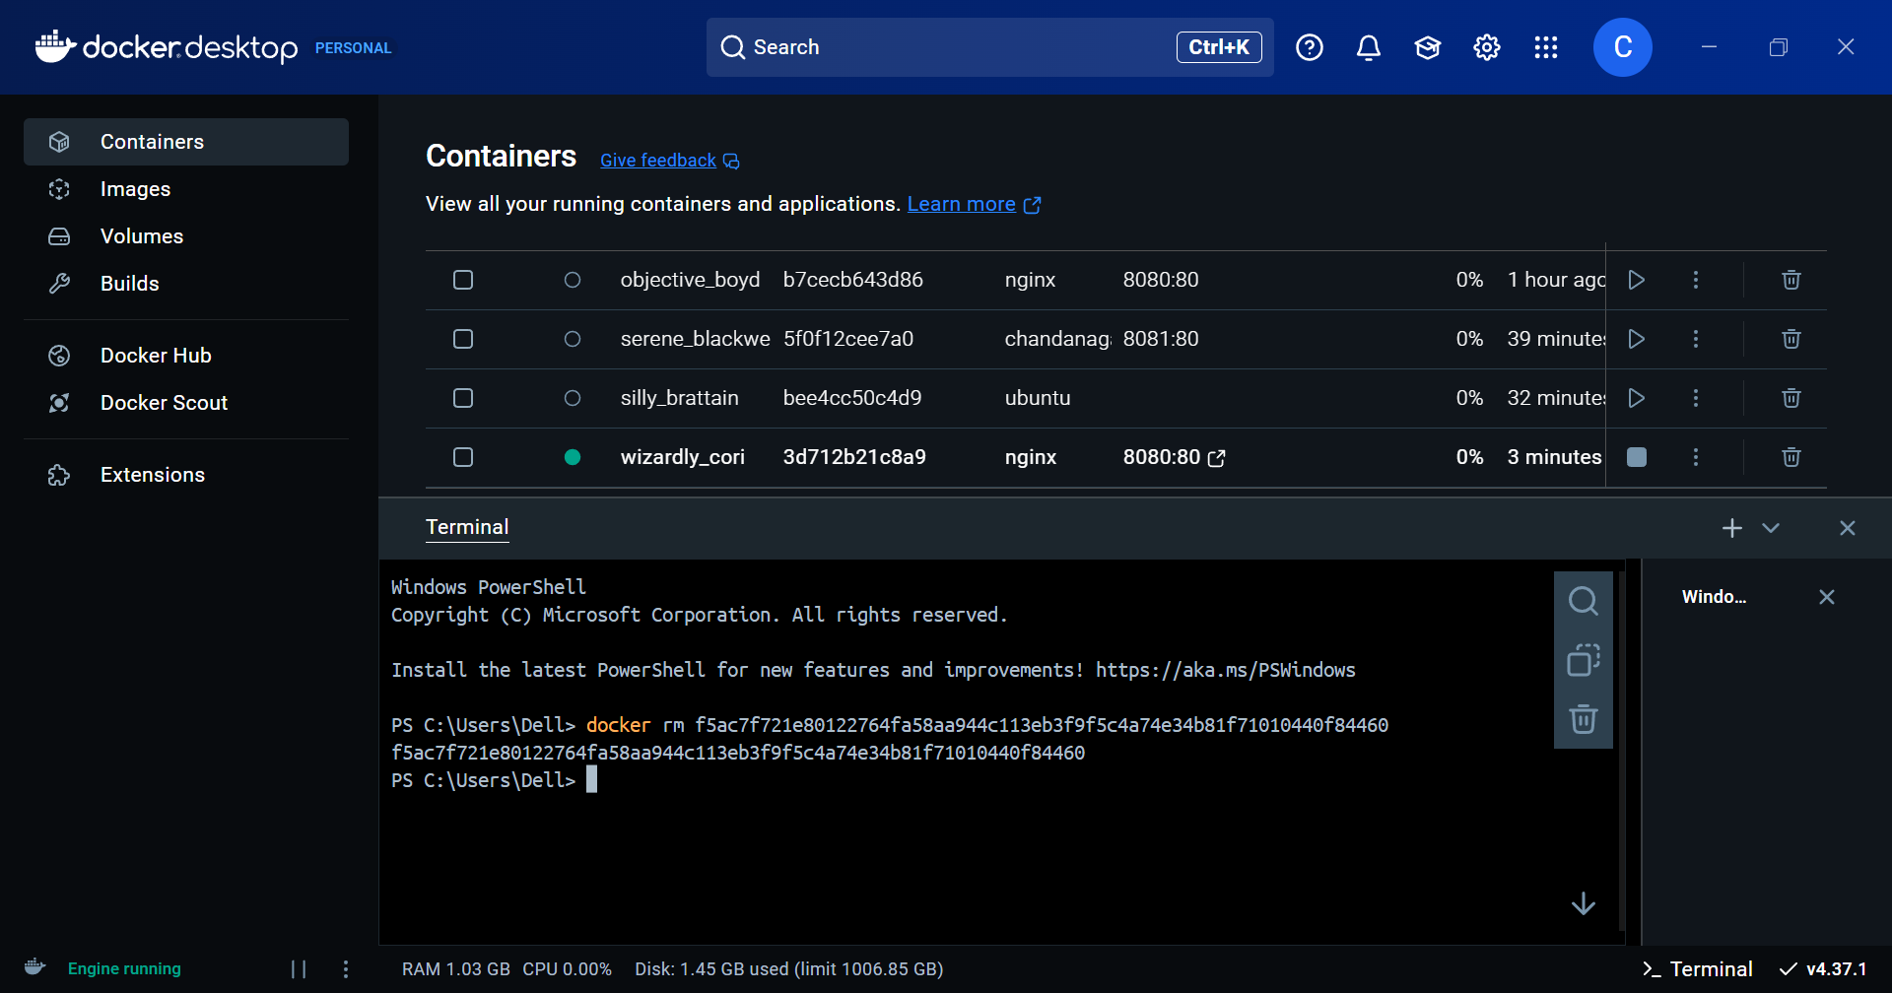

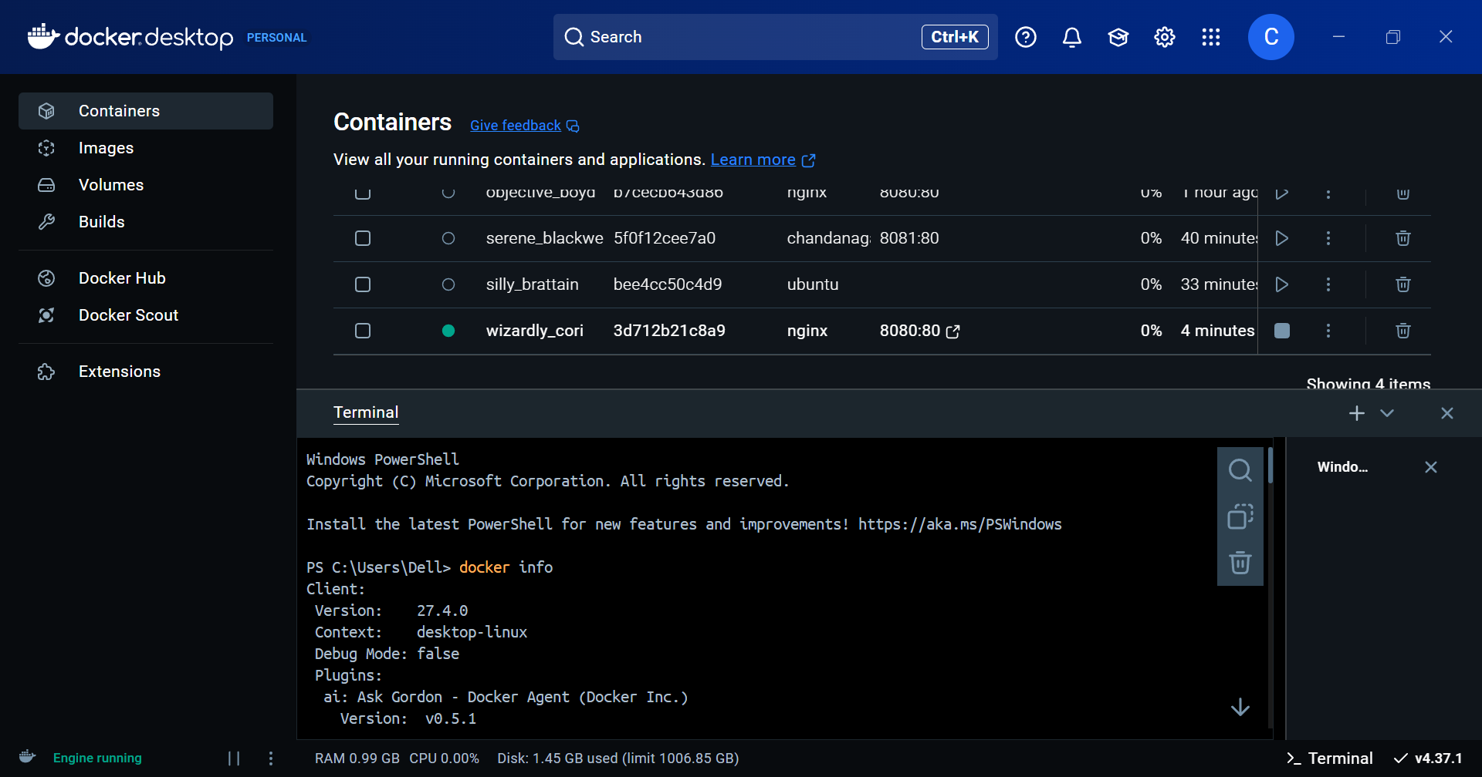

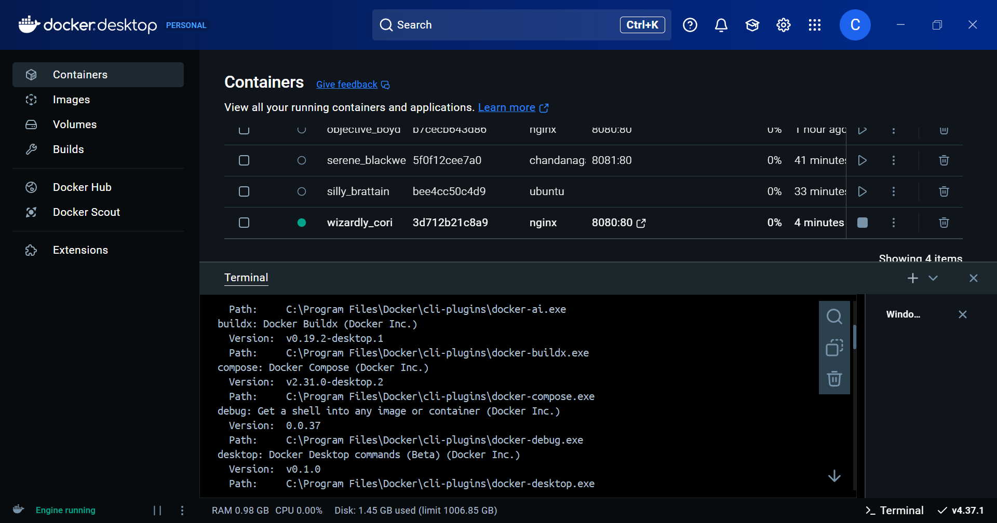

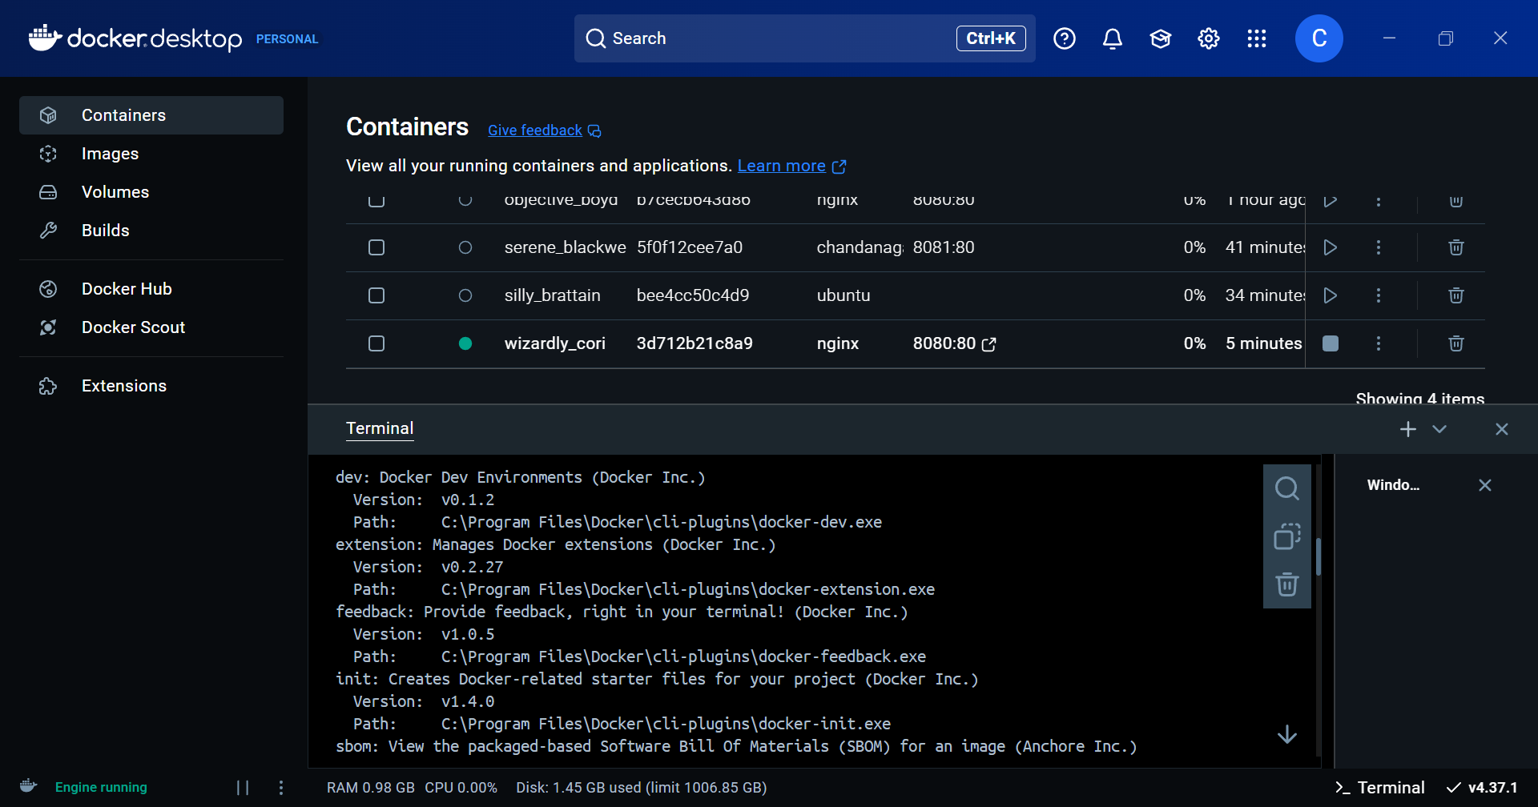

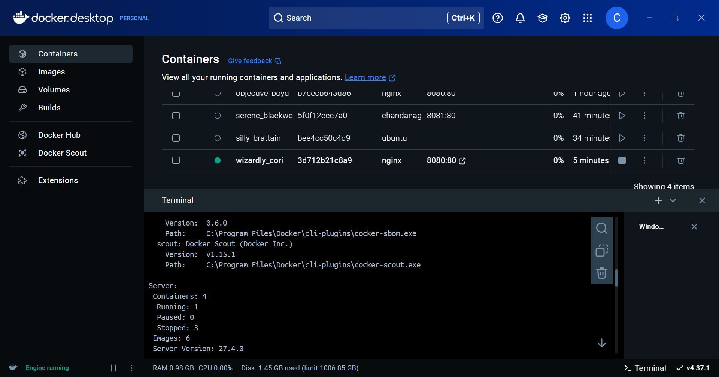

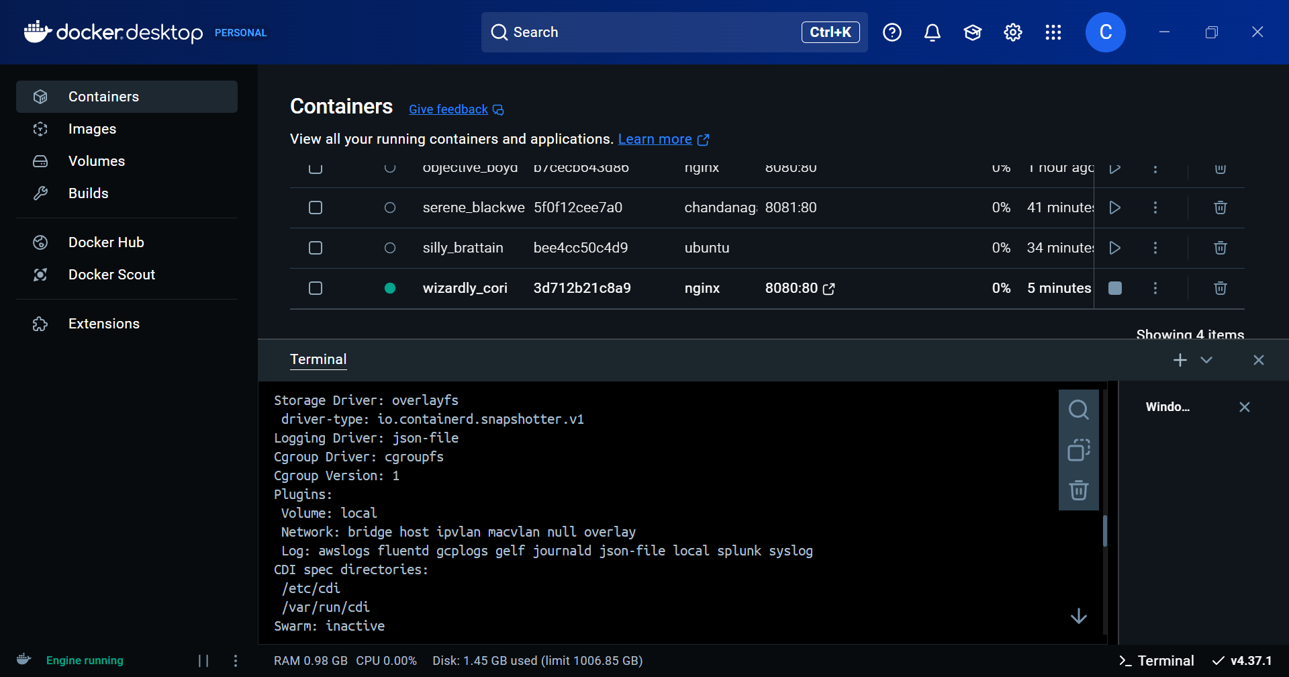

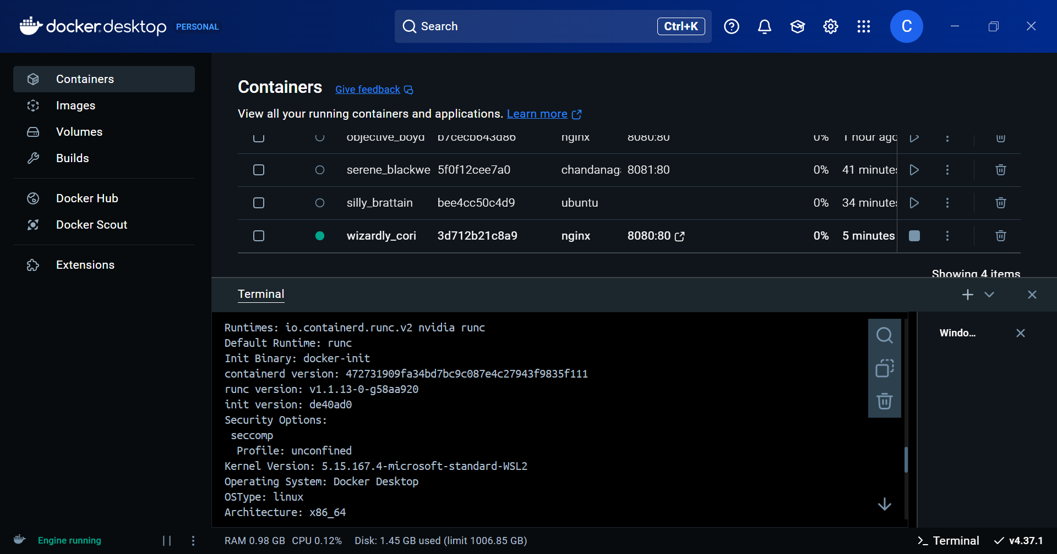

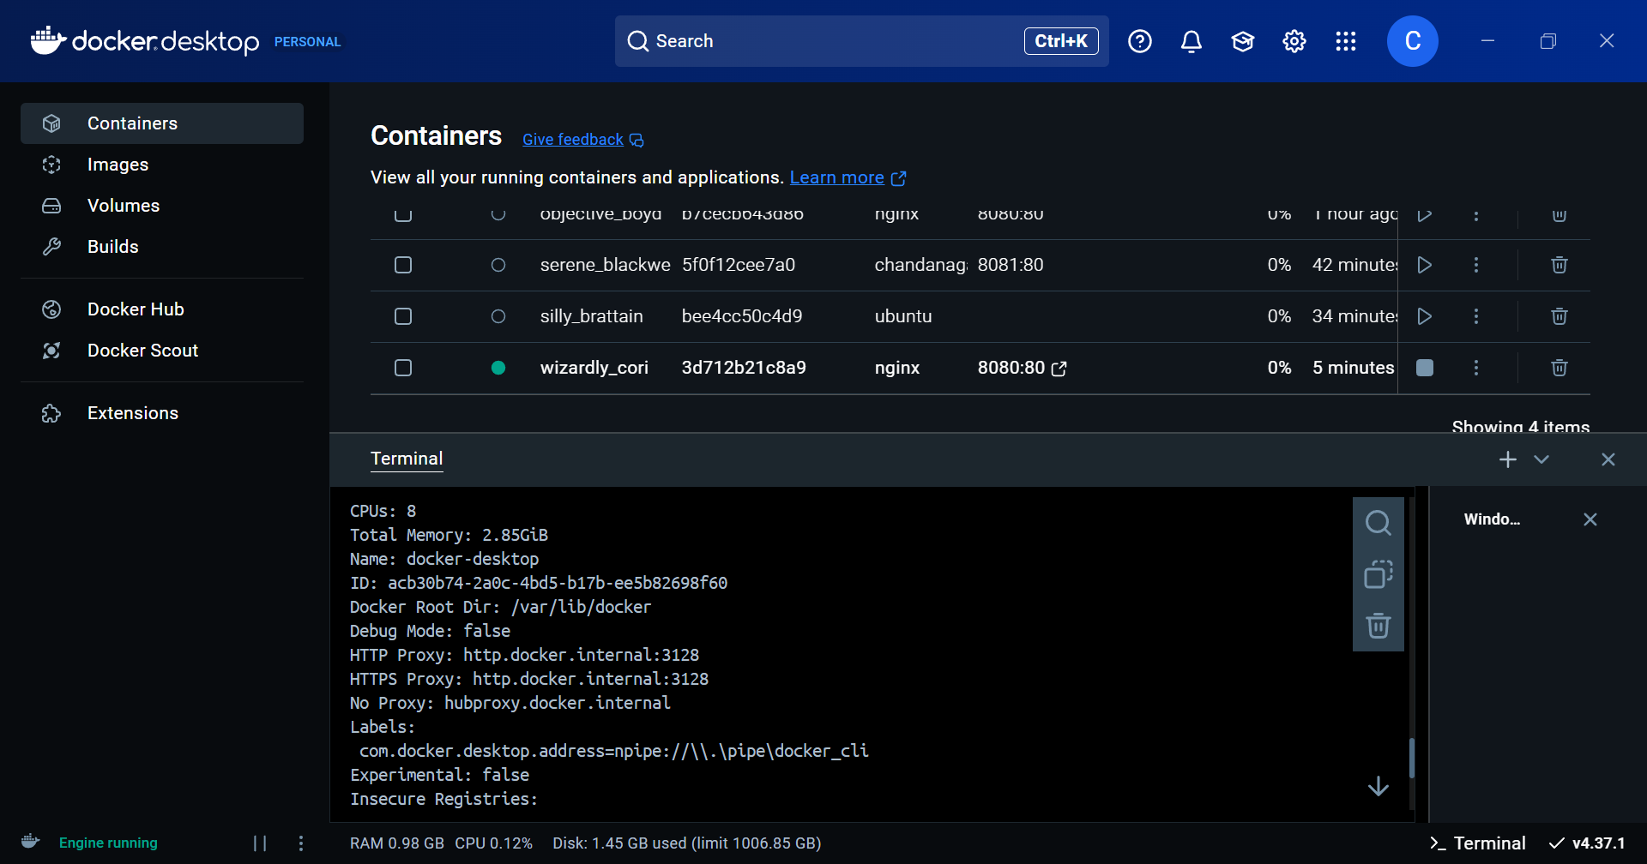

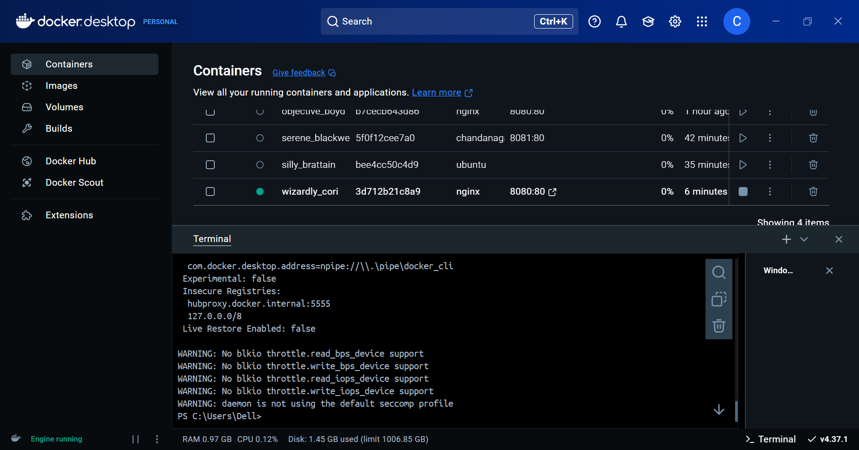

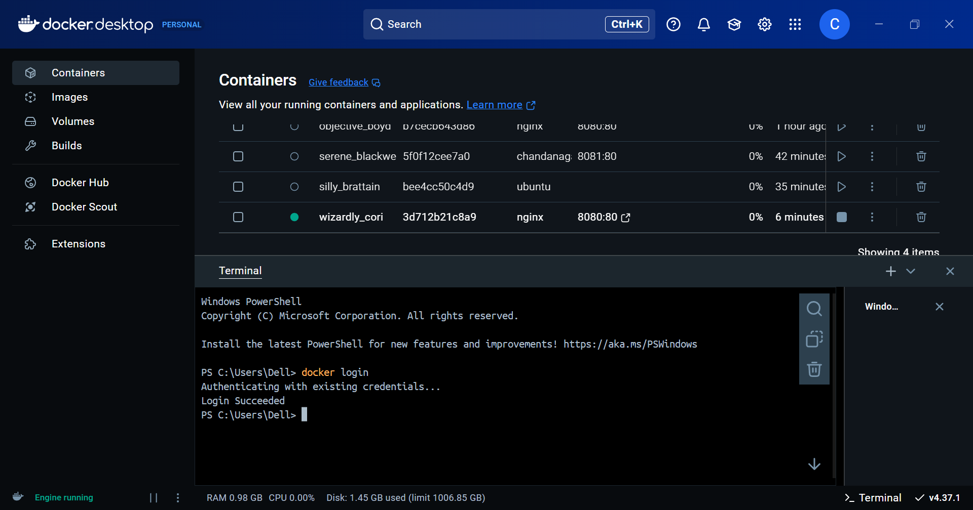

**__________________________________________________________________________**

**Questions:**

**What is a Docker file?**

**Ans:** A Dockerfile is a text document that contains a set of instructions to automate the creation of a Docker image. It specifies the base image, software packages, configurations, and commands to set up an environment. The Dockerfile is used by the Docker engine to build images automatically by reading the instructions line-by-line.

**__________________________________________________________________________**

**Outcomes:**

**CO1 – Understand Virtualization**

**CO3 – Analyze different cloud architectures and IoT-cloud**

**__________________________________________________________________________**

**Conclusion: (Conclusion to be based on the Results and outcomes achieved)**

The experiment demonstrated the process of installing Docker, pulling and running images from Docker Hub, modifying containers, and pushing the modified images back to Docker Hub. The procedure helped understand the creation, management, and use of Docker images and containers, including hosting a web server (Nginx) and deploying applications. The practical exposure reinforced the concept of containerization and how it simplifies application deployment and portability.

**__________________________________________________________________________**

**Grade: AA / AB / BB / BC / CC / CD / DD**

**Signature of faculty in–charge with date**

**__________________________________________________________________________**

**References:**

**Books/ Journals/ Websites:**

1. [https://www.digitalocean.com/community/tutorials/how-to-install-and-use-docker-on- ubuntu-18-04](http://www.digitalocean.com/community/tutorials/how-to-install-and-use-docker-on-)
2. [https://www.simplilearn.com/tutorials/docker-tutorial/install-docker-on-windows](http://www.simplilearn.com/tutorials/docker-tutorial/install-docker-on-windows)
3. [https://www.simplilearn.com/tutorials/docker-tutorial/how-to-install-docker-on-ubuntu](http://www.simplilearn.com/tutorials/docker-tutorial/how-to-install-docker-on-ubuntu)
4. [https://www.whitesourcesoftware.com/free-developer-tools/blog/docker-images-vs- docker-containers/](https://www.whitesourcesoftware.com/free-developer-tools/blog/docker-images-vs-docker-containers/)
5. Docker Commands Tutorial: <https://www.edureka.co/blog/docker-commands/>
6. Docker Basic Commands | Docker Commands with Examples | Docker Commands Tutorial | Intellipaat: <https://www.youtube.com/watch?v=nXV6qihj5uw>
7. Docker Tutorial 7: nginx server inside container:

<https://www.youtube.com/watch?v=rwLfGe0U-zY>

1. [https://www.docker.com/blog/how-to-use-the-official-nginx-docker-image/](http://www.docker.com/blog/how-to-use-the-official-nginx-docker-image/)

**__________________________________________________________________________**